**CSE 644 INTERNET SECURITY**

**Attacks on TCP/IP Protocols Lab**

**Arunbalaji Sivakumar(asivak01@syr.edu)**

**Contents:**

Setup :………………………………………………………….. 2

Task 1:………………………………………………………….. 3

Task 2:………………………………………………………….. 8

Task 3:………………………………………………………….. 15

Task 4:………………………………………………………….. 18

Task 5:………………………………………………………….. 23

Task 6:………………………………………………………….. 25

Task 7:………………………………………………………….. 30

Task 8:………………………………………………………….. 38

Investigation:…………..……………………………………….. 43

**Setup:**

Attacker Victim Observer

IP: 192.168.56.101 IP: 192.168.56.104 IP: 192.168.56.103

MAC:08:00:27:e7:ab:b1 MAC:08:00:27:7d:59:a0 MAC:08:00:27:47:a4:88

| | |

|____________________________ |_________________________| Fake machine

| LAN or Virtual Network | IP : 192.168.56.105

| Gateway 192.168.56.100 | MAC: aa:aa:aa:aa:aa:aa

|___________________ _________ _____________ ____________|

|

Internet

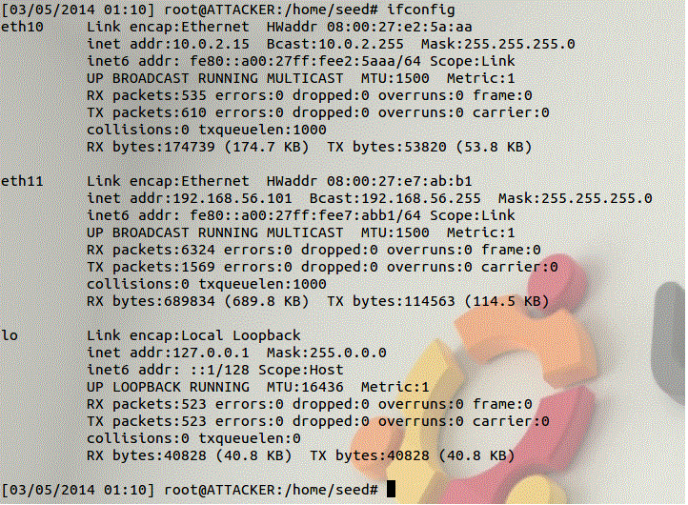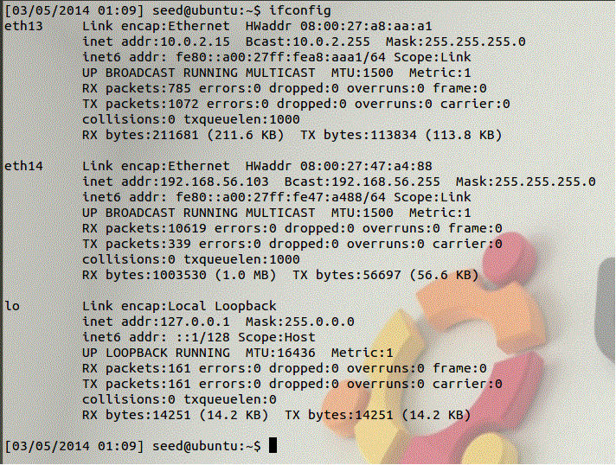

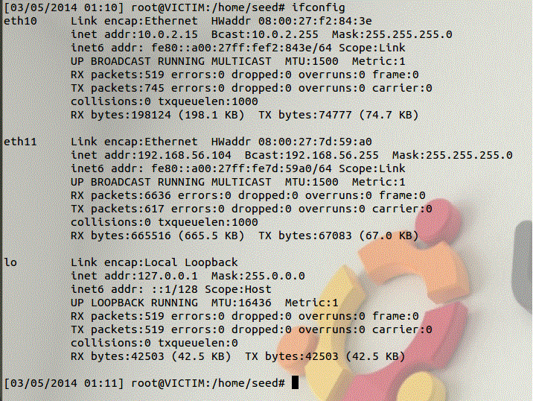

**Task 1: ARP cache poisoning**

Address Resolution Protocol (ARP) is used by IPv4 to map IP address in network layer to hardware address in data link layer. Whenever a host machine wants to communicate to another machine (destination) it sends out a broadcast ARP request to get the MAC address of the destination machine. After receiving ARP reply from the destination machine the host can send packets to the destination machine through the MAC address. ARP cache stores these MAC addresses in host machine. Thus if an attacker can modify the ARP cache of a victim machine he/she can compromise the victim and can perform various attacks on it.

**Initial conditions:**

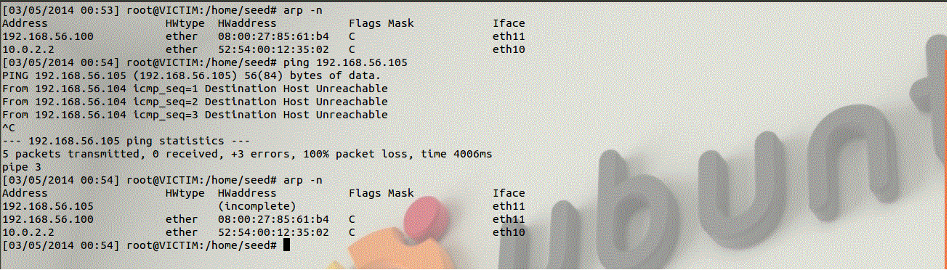

**Observation:**

The victim pings to an IP address whose MAC address is not known.

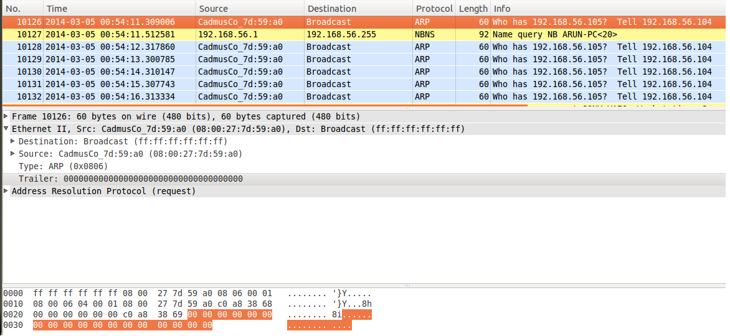

**Observation:**

The observer machine captures the packets sent by the victim machine. The attacker can also view these

packets through wireshark which can then be used to spoofing.

1. Can you issue the attack packets?

The attacker uses the netwox 56 tool to add an IP and MAC address entry into the victim’s ARP cache.

The attacker uses netwox 80 to send spoofed ARP reply so that victim will not ask for MAC address.

The attacker uses netwox 73 to redirect the ICMP packet to its own machine.

1. Can you add a new entry to the victim’s ARP cache?

ARP protocol is stateless and does not perform authentication so the attacker can spoof an ARP cache of

the victim machine. The attacker can pretend to be some other machine and can send an ARP request to

which the victim will reply without checking whether the sender’s IP is legitimate.



**Observation:**

Using Netwox 56 the attacker broadcasts single spoofed ARP request by identifying itself as

192.168.56.105 with a fake MAC address as aa:aa:aa:aa:aa

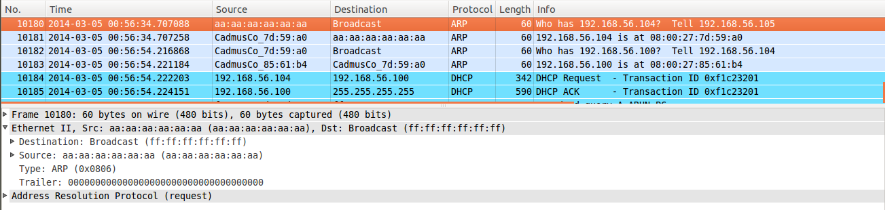

**Observation:**

The observer watches the packets sent by the attacker who asks the MAC address of the victim.

The victim replies to the request by sending its MAC address.

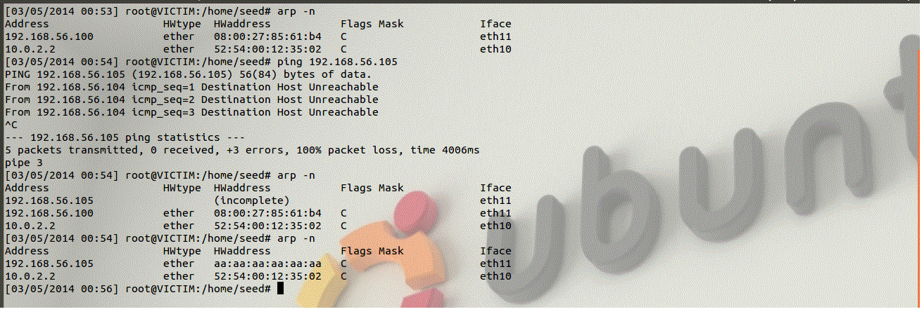

**Observation:**

After sending the ARP reply to the attacker the victim stores the attacker’s spoofed IP and MAC

Address in its ARP cache.

1. Can you modify one existing entry from the victim’s ARP cache?

As ARP is stateless the victim will accept multiple ARP responses containing the same MAC address and it

will store the last ARP response in its ARP cache. The attacker can take this as an advantage and can

change the victim’s ARP cache table.

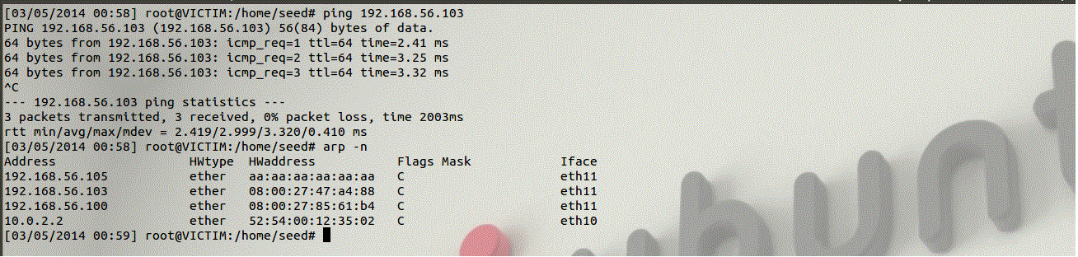

**Observation:**

The victim pings an existing IP (in this case it pings the observer) and stores the MAC address of

that IP in its ARP cache.



**Observation:**

The attacker spoofs the ARP cache of the victim using the Netwox 56. It identifies itself as

192.168.56.103 and provides its own MAC address.

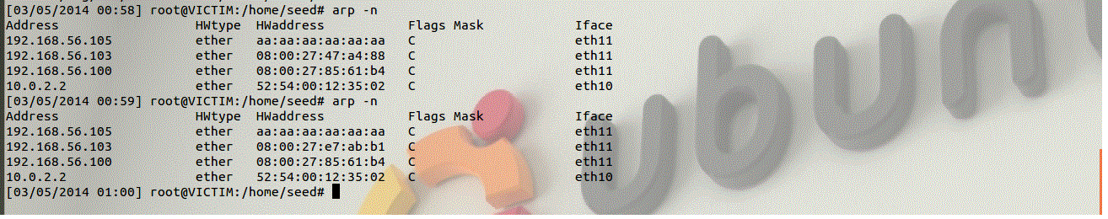

**Observation:**

After receiving ARP packets the ARP table is updated with fake MAC address for the IP

192.168.56.103.

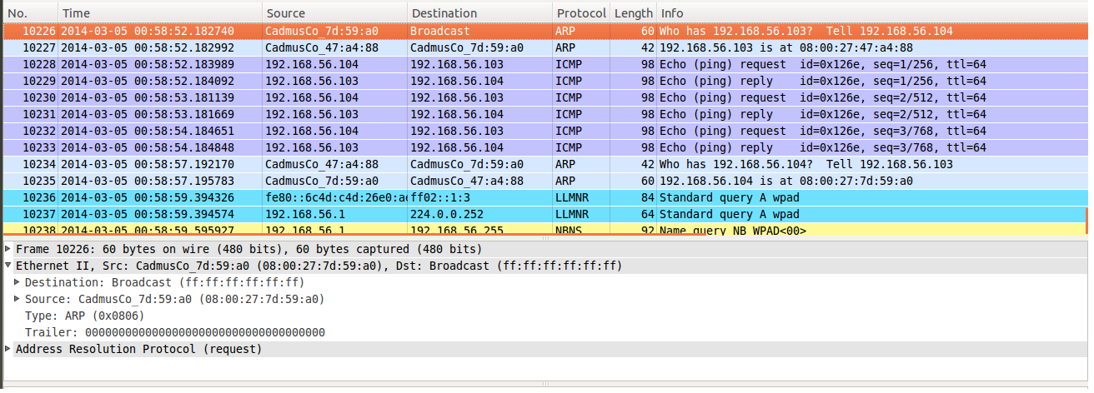

**Observation:**

The observer shows that initially when the victim asks for the MAC address for 192.168.56.103 it gets

08:00:27:47:a4:88. After the attacker sends the spoofed ARP packet the victim receives the MAC

address for 192.168.56.103 as 08:00:27:e7:ab:b1 which is the MAC address of the attacker.

1. If you can, can you deny the service of the victim machine? (ping)

Once the attacker compromises the victims ARP table he/she can modify the ARP cache so that when the victim sends any ping request it will not receive any reply.



**Observation:**

The victim machine has the spoofed MAC address for the IP 192.168.56.103. When the victim sends a ping request packet to 192.168.56.103 using the spoofed MAC address it will not receive any ping reply so it will again broadcast an ARP request requesting the MAC address of 192.168.56.103. To avoid this, the attacker uses netwox 80 to send an ARP reply to 192.168.56.103 at a regular interval of 1 second so the victim will not broadcast any ARP request until it’s time to refresh.

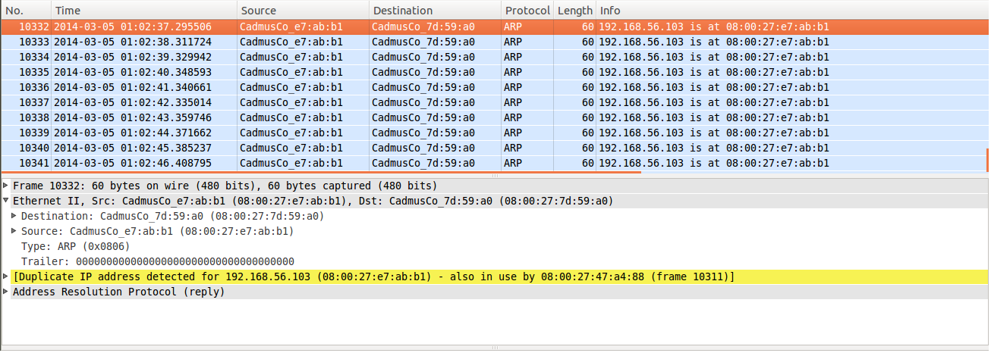

**Observation:**

The observer can see the ARP packet sent by the attacker to the victim.

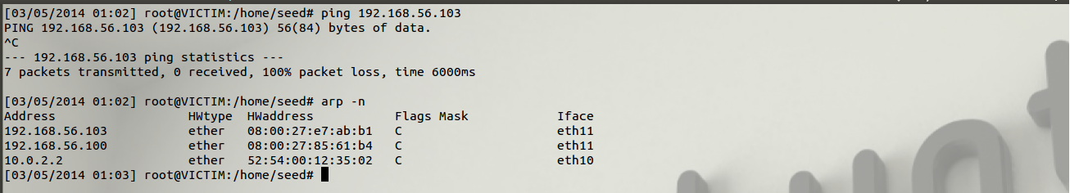

**Observation:**

The victim tries to ping 192.168.56.103 but does not receive ping reply. It does not send ARP request

since the ARP cache is being updated every second.

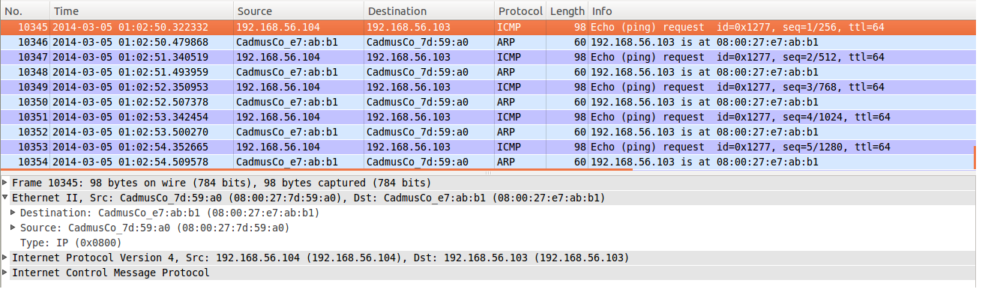

**Observation:**

The observer can see the ICMP request packets sent by victim and the spoofed ARP reply sent by the

attacker machine.

1. Can you redirect the traffic to your own machine?

Once the ARP cache of the victim is compromised the attacker can modify the table to redirect any packet sent from the victim to it.



**Observation:**

The attacker uses netwox 73 to listen to any packet containing the destination IP as 192.168.56.103 and the destination MAC address as 08:00:27:e7:ab:b1. When it receives such packet it sends out a corresponding spoofed reply to the sender machine. By this way the victim will keep sending the packets to the destined MAC address instead of the original MAC address.

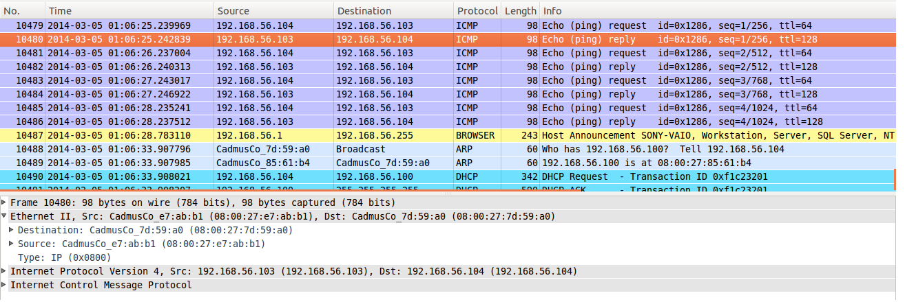

**Observation:**

The observer can see the ICMP request and reply but the reply is sent from the spoofed MAC address.

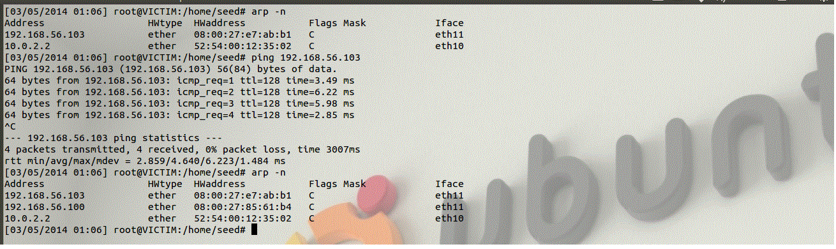

**Observation:**

The victim pings 192.168.56.103 and receives the spoofed ICMP reply from the attacker.

**Task 2: ICMP redirect attack**

When two machines want to communicate with each other the router has to find the shortest path between them. If there is an alternate path between the two machines and if it is shorter than the previous path then the router will send an ICMP redirect packet to the sender machine to change its routing table so that it uses the shortest path which has minimum hops. However such ICMP redirect packets can be forged by a malicious machine and make the sender machine to redirect its packet to the attacker or to a non-existing IP.

1. Can you issue the attack packets?

The attacker can us the netwox 86 tool to send an ICMP redirect message to the victim. The syntax of the command is

netwox 86 –device <”decive”> --filter <”victim IP”> --gw<attacker or non-exist IP> --spoofip “raw” –code <icmp code> --src-ip <destination IP>

1. Can you modify one existing entry from the victim’s routing table cache? Change it to attacker’s IP.

The attacker can issue the ICMP redirect packets and successfully make the victim to send the packets to the attacker’s IP but cannot modify the routing table of the victim. Since the forged redirect packets comes from the destination the victim will use the gateway mentioned in that packet and will ignore the default gateway.

1. Can you modify one existing entry from the victim’s routing table cache? Change it to non-existing IP.

The attacker can issue the ICMP redirect packets and successfully make the victim to send the packets to a non-existing IP but cannot modify the routing table of the victim. Since the forged redirect packets comes from the destination the victim will use the gateway mentioned in that packet and will ignore the default gateway.

1. Is there any protection mechanism in UBUNTU? (secure_redirects: it only accept ICMP redirect messages for gateways, listed in default gateway list)

In order to prevent ICMP redirect attacks Ubuntu has mechanisms to ignore such redirect packets. This is done by modifying the lines in /etc/sysctl.conf file in the victim machine.

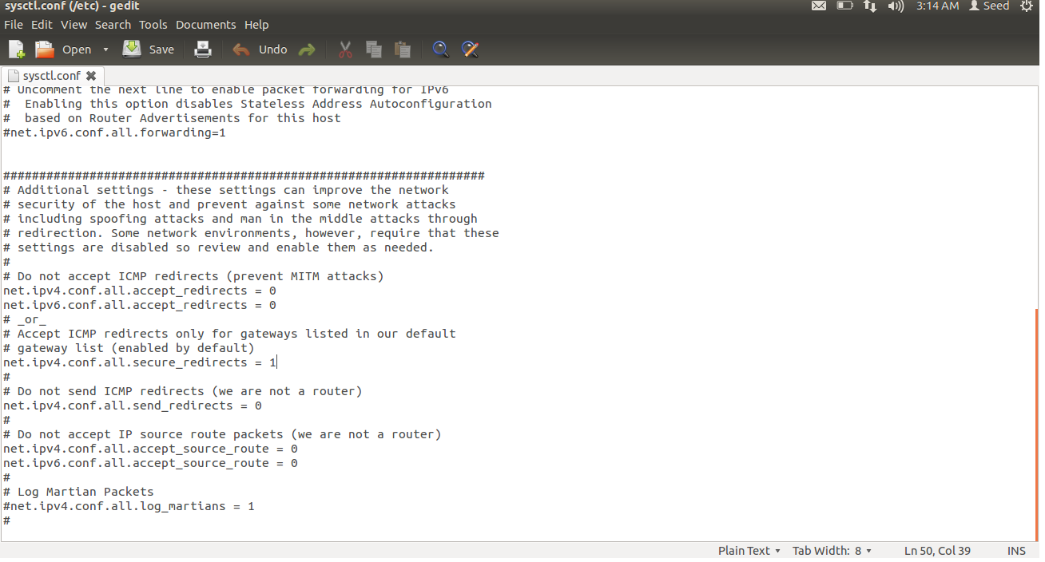

**Observation:**

The secure_redirects is enabled in the victim machine so it will accept ICMP redirect packets only from the default gateway. Other ICMP redirect packets are ignored by the victim. This will prevent the man-in-middle attack.

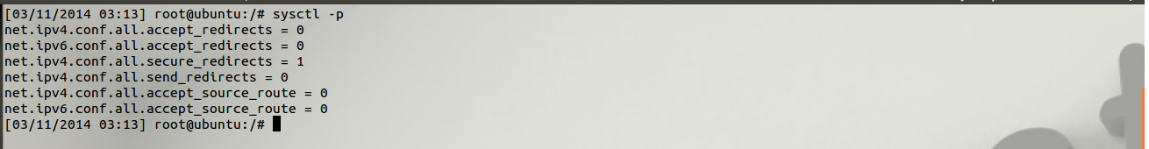

**Observation:**

The modification made in sysctl.conf file is restarted using the sysctl –p command in the terminal.

1. Repeat after you turn off the protection.

Non-existing gateway IP address:

To make the ICMP redirect work the victim machine must turn off its redirect protection mechanisms. This is done by modifying the /etc/sysctl.conf file in the victim machine.

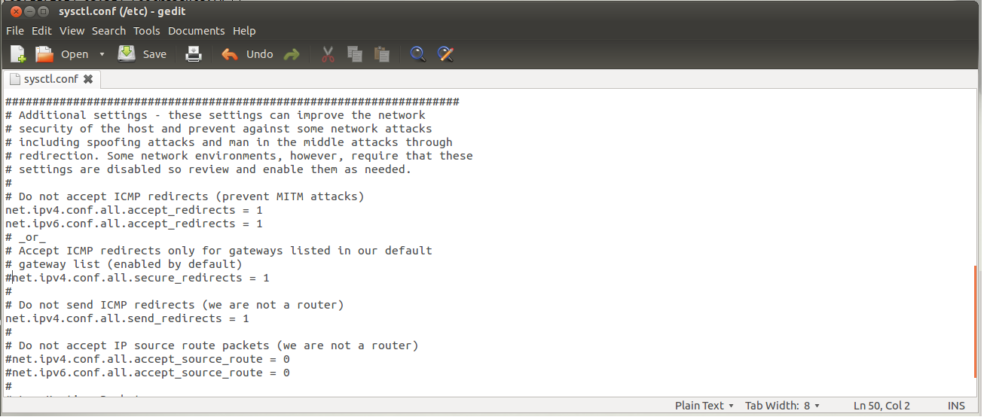

**Observation:**

The victim machine can receive ICMP redirect request from any IP and it will accept any mentioned gateway to transfer packets.



**Observation:**

The modified sysctl.conf file is updated using sysctl -p in the terminal.

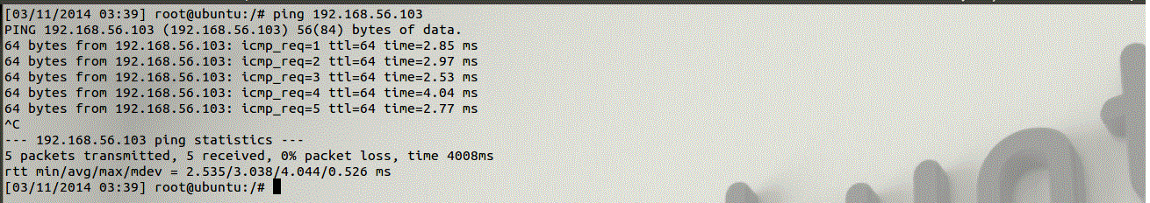

**Observation:**

When there is no attack victim can directly send ping packets to the observer machine and the observer can also ping back without any redirection.



**Observation:**

The victim can see the path taken to reach the observer.

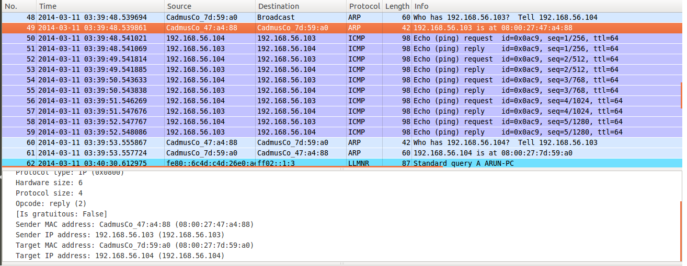

**Observer:**

The attacker watches the packets being sent between the victim and the observer.



**Observation:**

The attacker generates a spoofed ICMP redirect packet which will be sent to the victim IP and will ask the victim to use the gateway 192.168.56.105 which is non-existing. the victim will see the packet being sent by the observer.

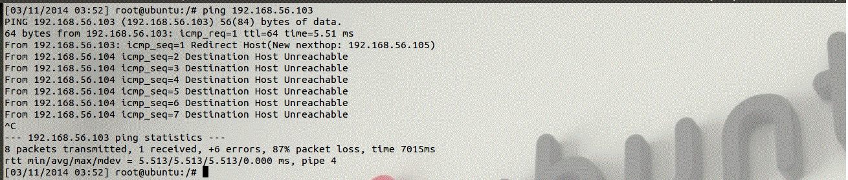

**Observation:**

When the victim again pings the observer it receives an ICMP redirect message from the observer to use the gateway 192.168.56.105 to send the packets. The victim cannot find the MAC address of the gateway resulting to the destination host unreachable and the denial of service attack.



**Observation:**

The victim can see the packet being sent through 192.168.56.105

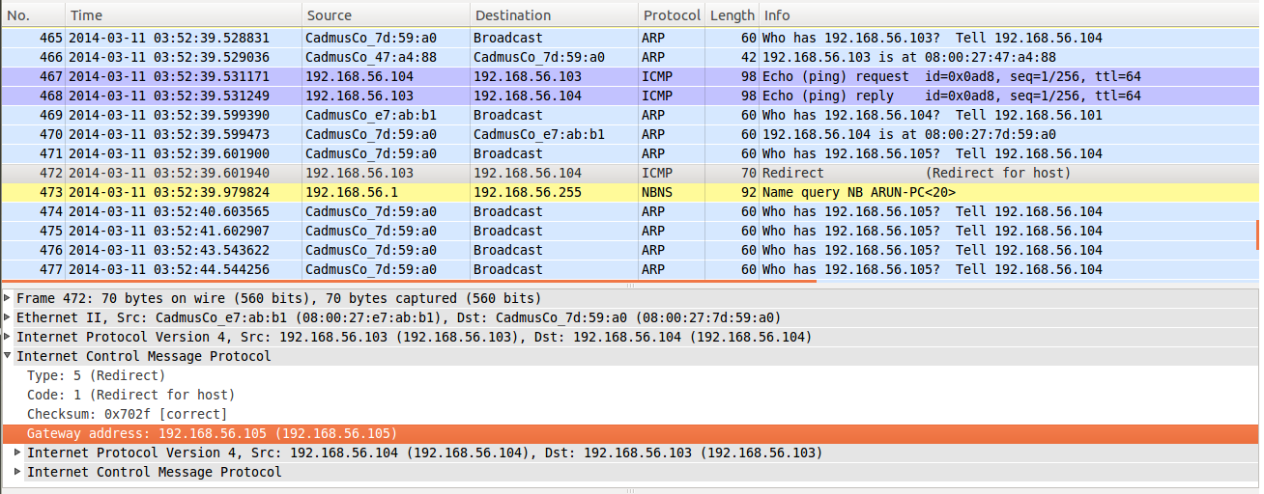

**Observation:**

The attacker can see the redirect packet making the victim to use the IP 192.168.56.105 as the gateway to communicate with the observer.

Gateway as attacker’s IP address:



**Observation:**

The attacker generates a spoofed ICMP redirect packet which will be sent to the victim IP and will ask the victim to use the gateway 192.168.56.101 which is the IP address of the attacker. The victim will see the packet being sent by the observer.

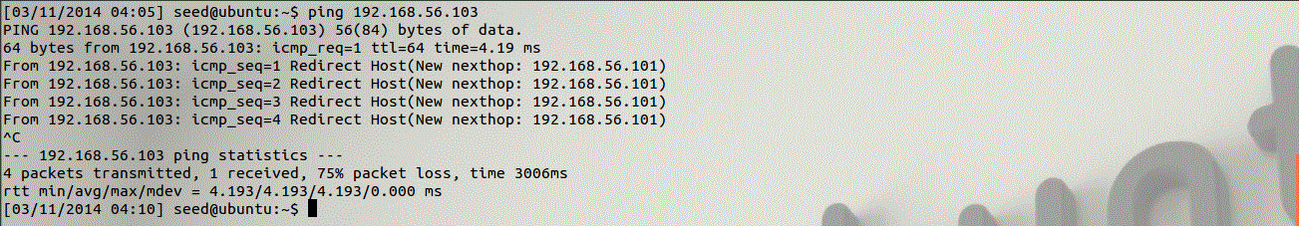

**Observation:**

When the victim again pings the observer it receives an ICMP redirect message from the observer to use 192.168.56.101 as gateway to send the packets. When the victim sends the packet through 192.168.56.101 the packet is not transferred.

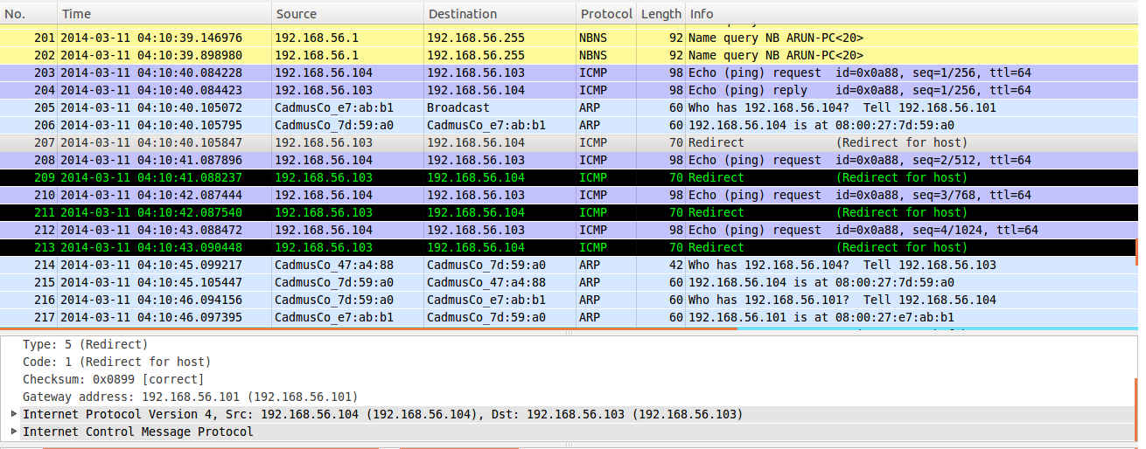

**Observation:**

The attacker can see the redirect packet making the victim to use the IP 192.168.56.101 as the gateway to communicate with the observer.

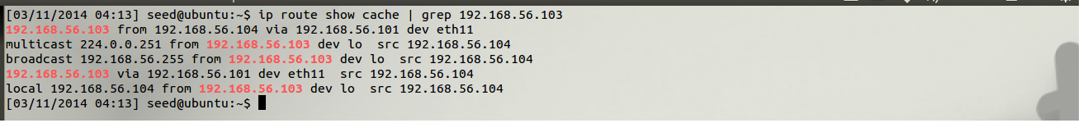

**Observation:**

The victim can see the packet being sent through 192.168.56.101

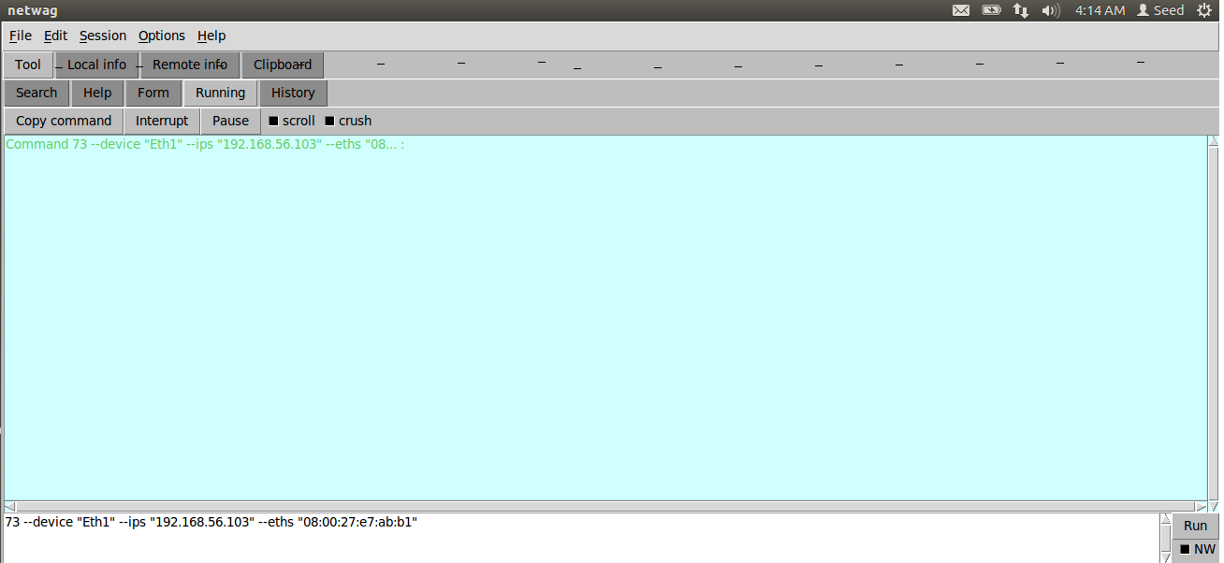

**Observation:**

The attacker uses netwag 73 to send out a spoofed icmp reply to the victim.

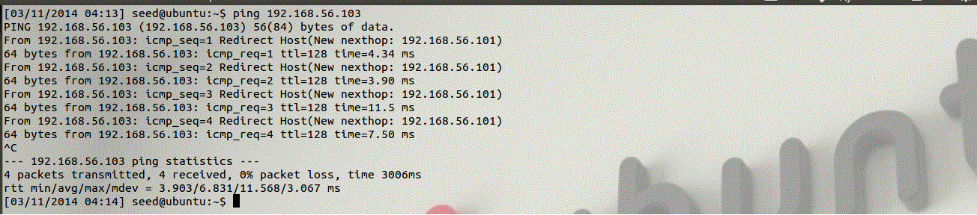

**Observation:**

The victim receives icmp reply from the observer which is actually the spoofed icmp packet sent by the attacker.

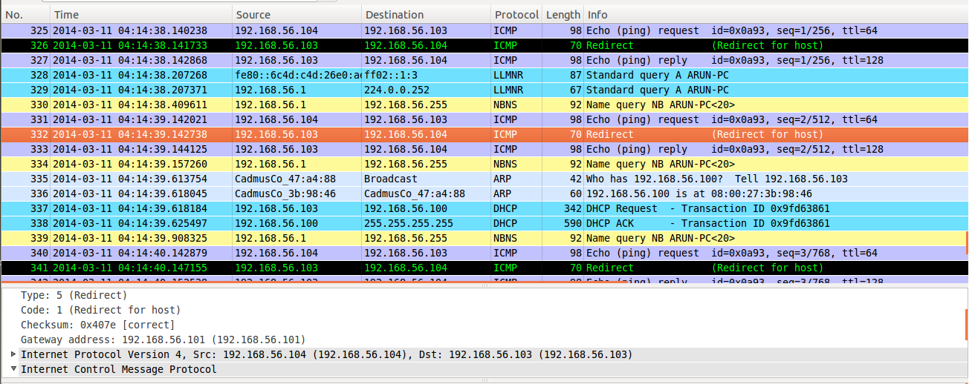

**Observation:**

The attacker can see the icmp packet being sent through the gateway.

**Task 3: SYN Flooding Attack**

SYN flood is an attack in which the attacker machine sends a lot of spoofed SYN request packets to the victim machine to which the victim will try allocate its resources to those packets. So any future legitimate request will be discarded. This is a form of denial of service attack.

1. Can you issue the attack packets?(wireshark)

Using the netwox 76 tool the attacker can create a spoofed TCP SYN request packet and send it to the victim. The syntax of the command is,

netwox 76 --dst-ip <victim IP address> --dst-port <victim port number> --spoofip “<packet type>”

1. Protection from UBUNTU

UBUNTU provides different ways to prevent SYN flood attacks. One such prevention mechanism is the use of SYN cookies. SYN cookies can avoid dropping SYN request packets when the SYN queue is full. Instead they make the queue as if it is enlarged and send back SYN-ACK response and discards further SYN requests. If it receives any ACK response it will update the queue using the TCP sequence number. By default the SYN cookie is disabled. But it can be changed by modifying the content in etc/sysctl.conf .

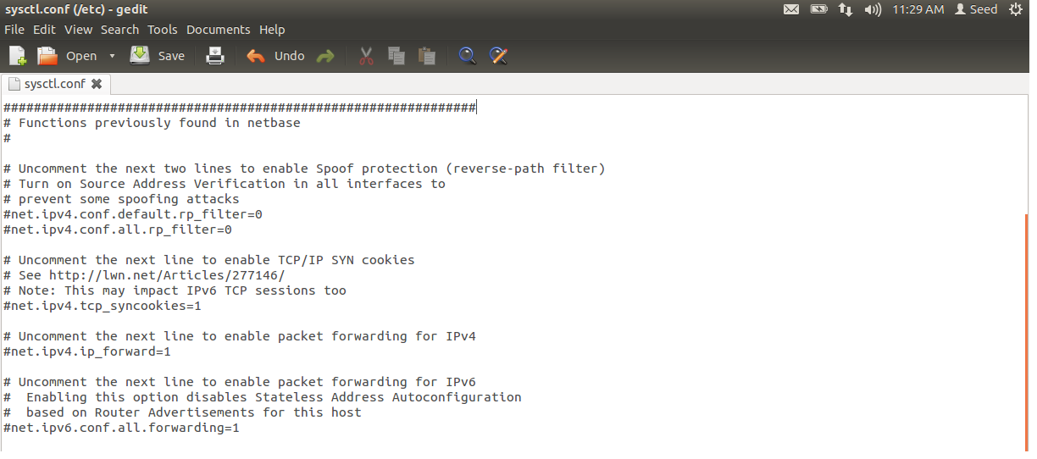

**Observation:**

The TCP SYN cookie line is commented initially.

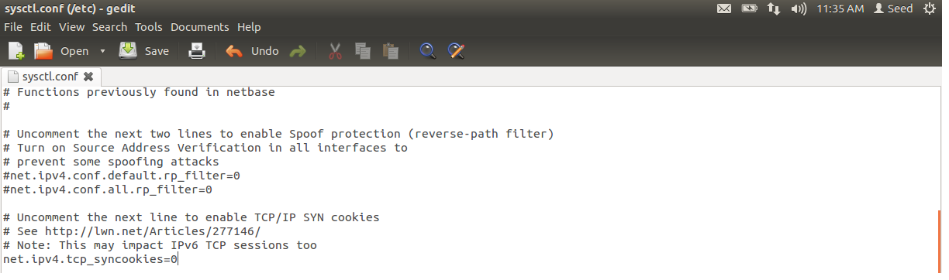



**Observation:**

SYN cookie is disabled in etc/sysctl.conf file. By disabling the cookie SYN-ACK response will not be sent when the queue is full.

1. TCP SYN queue size?(tcp_max_syn_backlog = 1024)

The TCP SYN queue is used to contain the SYN requests. Once the queue is full incoming SYN packets are dropped.



**Observation:**

By default the maximum size of syn_backlog queue is 128. It can be increased or decreased by adding the entry into the /etc/sysctl.conf file.

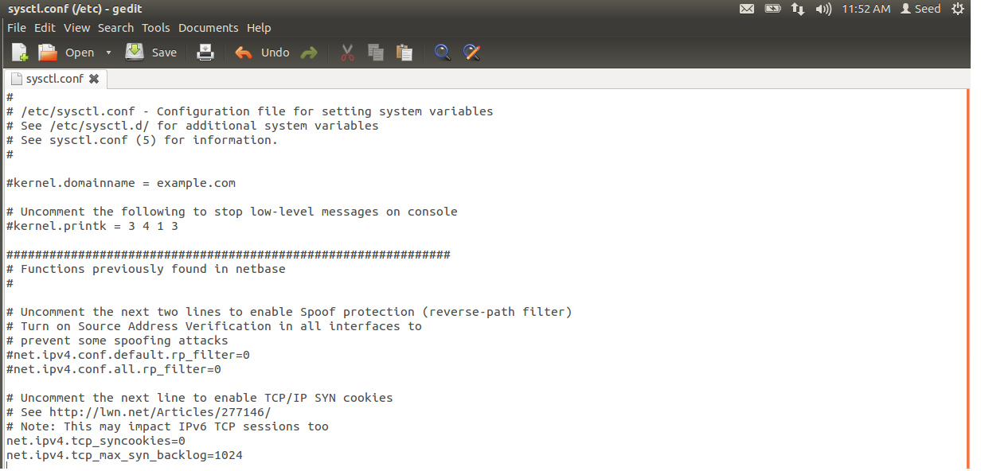

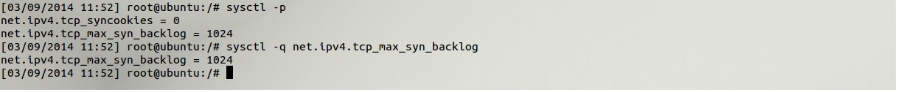

**Observation:**

The syn_backlog queue size is increased to 1024.

1. Can you see the “SYN_RECV” typed connection on the victim machine?(netstat)

Before SYN flooding, when the victim machine receives any SYN packet it will send a SYN-ACK packet back to the sender and again the sender will send an ACK packet. Thus the 3-way hand shake would be made and the connection would be complete. During SYN flooding the attacker will send a lot of SYN packet to the victim and the victim will respond with SYN-ACK packet and place the SYN packet in the syn_backlog queue. But the attacker will not send the ACK packet so the 3-way hand shake will not be complete and the packets stay in the queue and the status will be SYN_RECV.

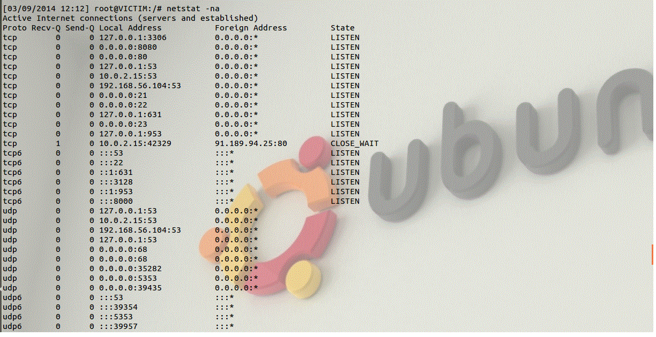

**Observation:**

Initially in the victim machine all ports are open and listening for any incoming packets.



**Observation:**

The attacker used netwox 76 to send spoofed SYN request to the victim under port 80. The packet type must be raw or else the attacker would send an ARP request for the MAC address of the spoofed source IPs (best).

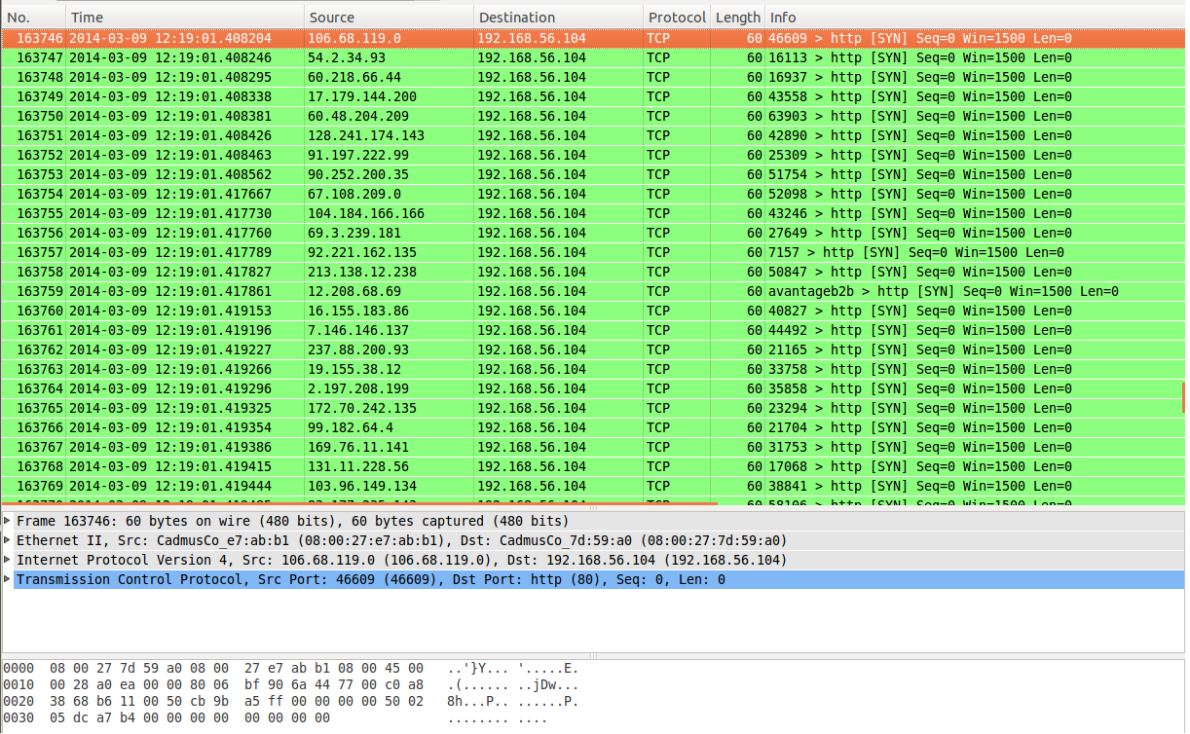

**Observation:**

The observer can see the spoofed TCP SYN packets with different IP address being sent to the victim.

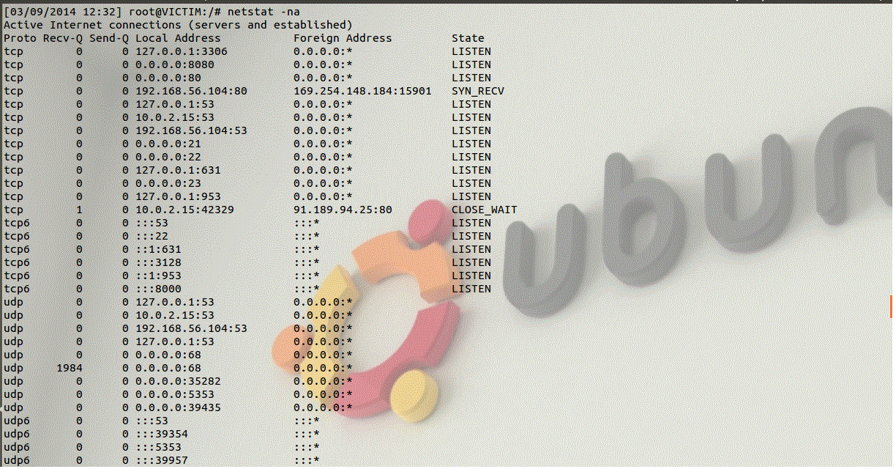

**Observation:**

As the victim’s syn queue gets filled up it sends out the SYN-ACK packet and waits for the ACK which can be seen as SYN_RECV which indicates that the connection is in half opened state.

1. What’s your observation? Can you deny the service of victim machine?

As the attacker floods the syn queue of the victim, the victim machine becomes slow to response and it tries to process all the packets with overload. However the attacker cannot provide denial of service on the victim.

The attack can be more effective if the following parameters are changed in victim machine.

* By reducing the syn queue size of the victim so that it soon runs out of spaces to place the incoming SYN packets.

net.ipv4.tcp_max_syn_backlog = 64

The above statement should be placed in the /etc/sysctl.conf file.

The default size is



* By increasing the value of synack_retries the closing time of SYN_RECV is increased so the packet stay longer in the queue.

net.ipv4.tcp_synack_retries = 10.

the default value is



* By disabling the IP spoofing filter which prevents any spoofed packets.

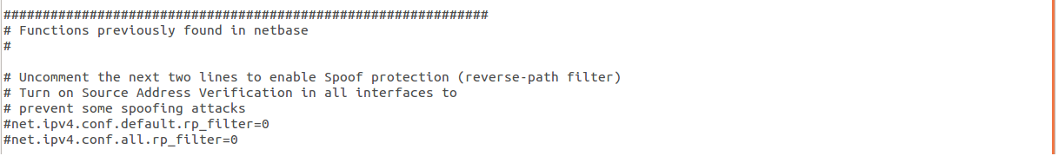

**Task 4: TCP RST Attacks on telnet Connections**

TCP reset is form of terminating a TCP connection between two computers. When one computer wants to terminate a TCP connection it sends out a TCP packet with the RST flag set to 1 to the other computer. However such TCP reset packets can be forged by an attacker machine in the same LAN. The forged packet’s header must contain the IP address of one of the connected machines.

**telnet:**

1. Can you issue the attack packets?

TCP RST packets can be generated and sent by the attacker through the netwox 78 tool. The syntax of the command is

Netwox 78 --device <”device”> --filter <”filter parameter”> --spoofip <”packet type”> --ips <”destination ip”>

1. Establish telnet connection.

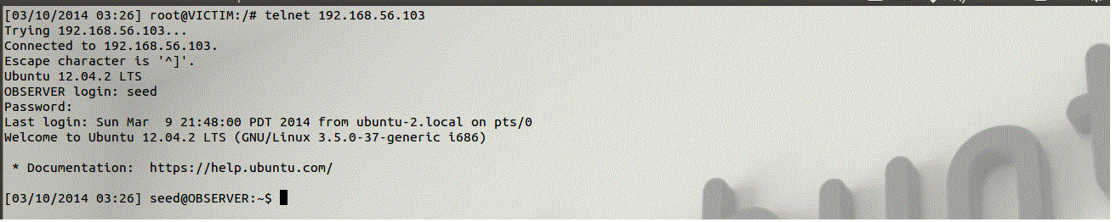

**Observation:**

When there is no TCP RST attack the victim can make a telnet connection to the observer.

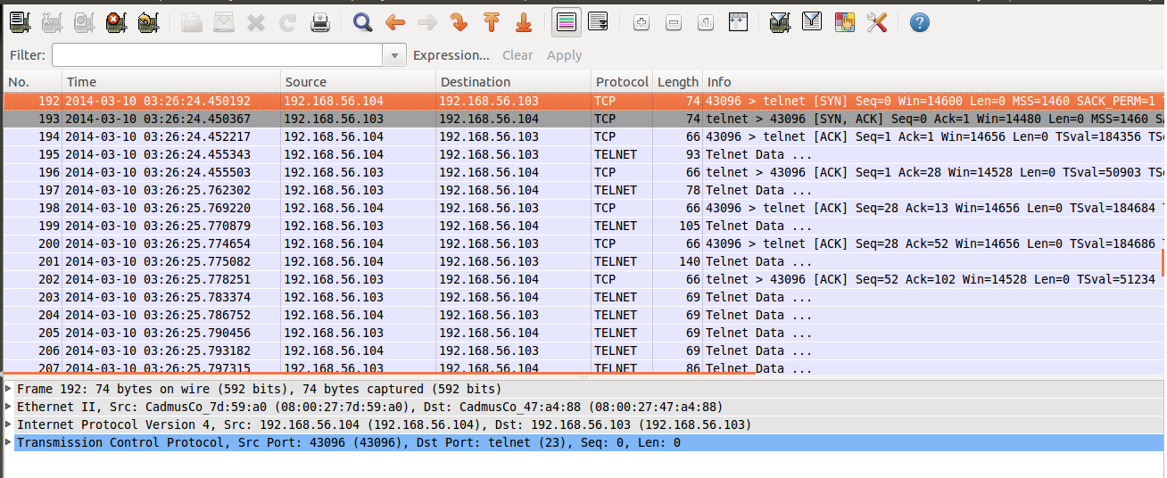

**Observation:**

The attacker watches the packet being sent between the victim and observer.

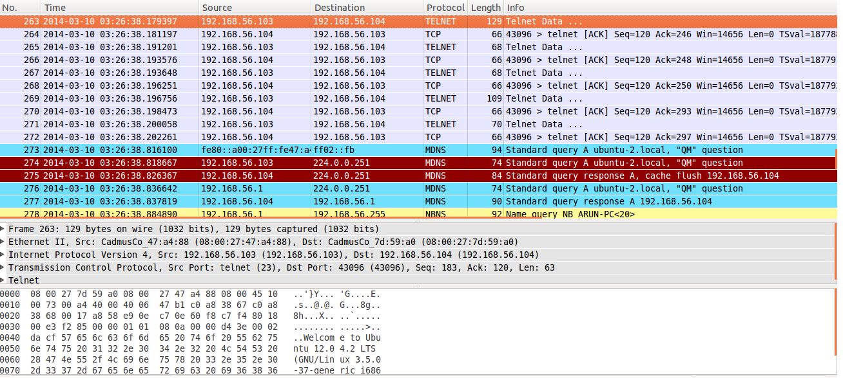

**Observation:**

The attacker sees the connection being made between the two machines with the welcome packet sent from observer to victim.



**Observation:**

After the connection is established the victim can view the files of the observer.

1. After the attack, what happned to the telnet connection? Will it be broken?



**Observation:**

The attacker sends out the forged TCP RCT packet to the victim by modifying the source IP address as observer. The filter can also be changed to host 192.168.56.104 and dst port 23.

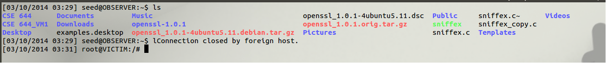

**Observation:**

The attacker prepares and waits for any victim packet in LAN. Once the victim types any further command inside observer the TCP RST packet is sent to the victim and forces it to terminate the telnet connection.

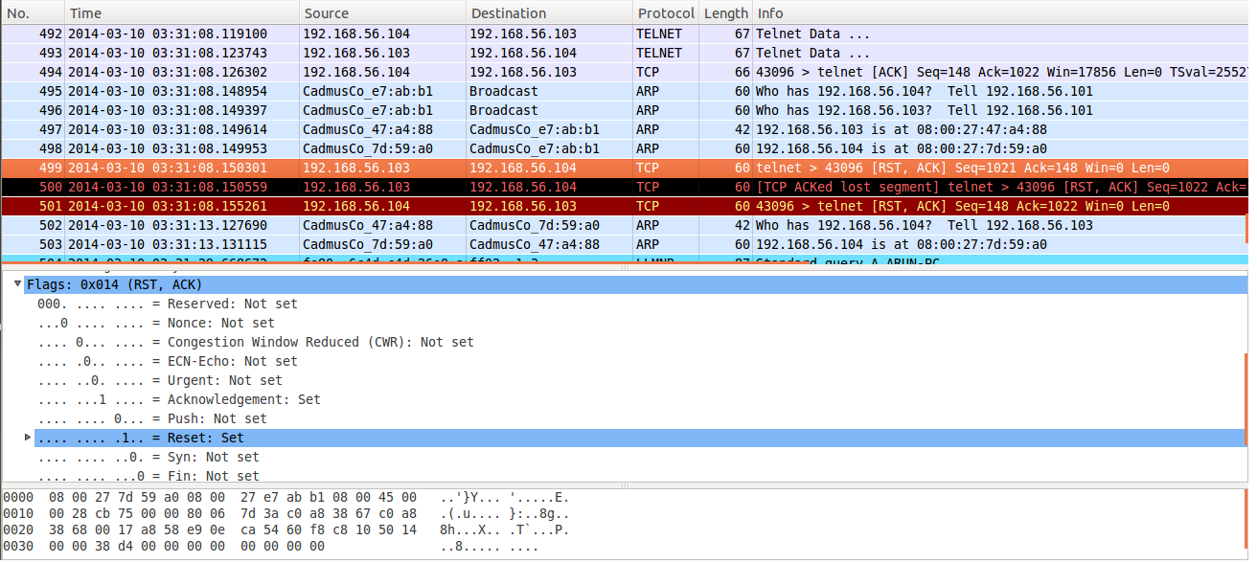

**Observation:**

The attacker can see the TCP RST packet sent by the observer to the victim forcing it to terminate the connection.

**SSH connection:**

1. Can you issue the attack packets?

TCP RST packets can be generated and sent by the attacker through the netwox 78 tool. The syntax of the command is

Netwox 78 --device <”device”> --filter <”filter parameter”> --spoofip <”packet type”> --ips <”destination ip”>

1. Establish the SSH connection.

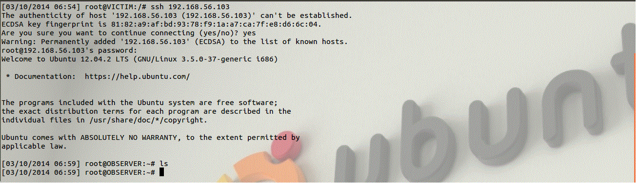

**Observation:**

Before the attack the victim can make ssh connection with observer.

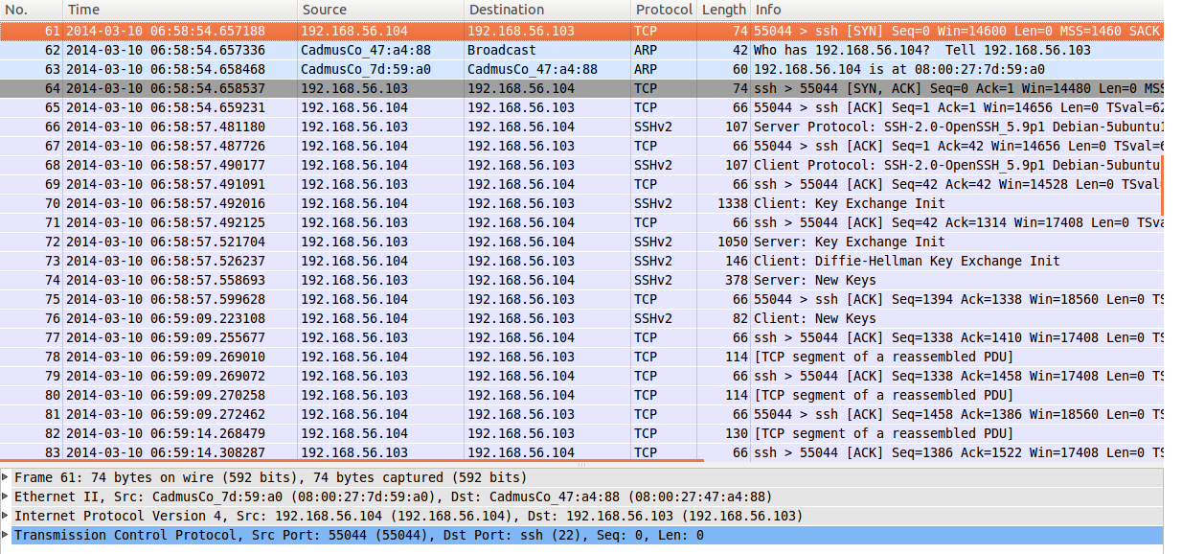

**Observation:**

The attacker watches the ssh packets sent between victim and the observer.

1. After the attack, what happened to the ssh connection? Will it be broken?



**Observation:**

The attacker generates a forged TCP RST packet using netwox 78 and listens to any packet with the port number 22.

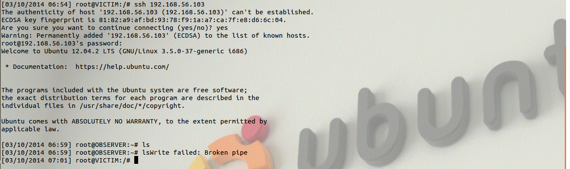

**Observation:**

When the victim tries to do some work in the observer machine the SSH connection is force terminated by the observer.

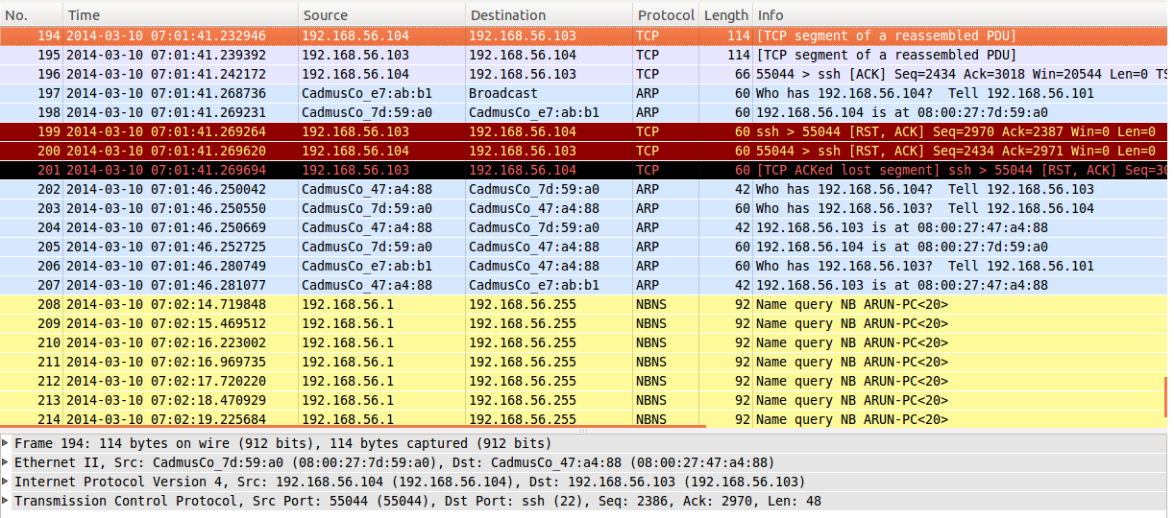

**Observation:**

The attacker watches the forged TCP RST packet terminating the SSH connection.

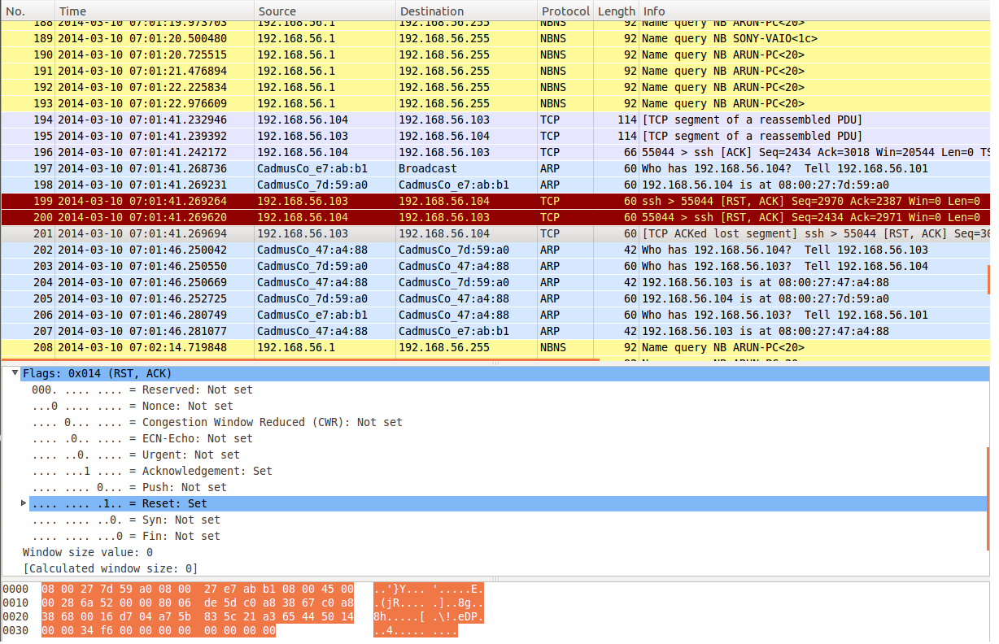

**Observation:**

The attacker watches the TCP RST packet with the RST flag set to 1.

**Task 5: TCP RST Attack (online video)**

TCP RST attack can be done on any TCP packet. One such attack is to block the online streaming video by sending a forged TCP reset packet to the victim machine.

1. Can you issue the attack packets?

TCP RST packets can be generated and sent by the attacker through the netwox 78 tool. The syntax of the command is

Netwox 78 --device <”device”> --filter <”filter parameter”> --spoofip <”packet type”> --ips <”destination ip”>

1. Can you watch an online video?



**Observation:**

The victim machine watches streaming video online. As there is no reset packet the video will keep on streaming.

**Within the same machine:**

1. After the attack, what happened to the video? Can you still watch it?



**Observation:**

The TCP RST packet is sent by the victim machine. The destination address is the 10.0.2.15 through which the packets are sent and received from NAT.

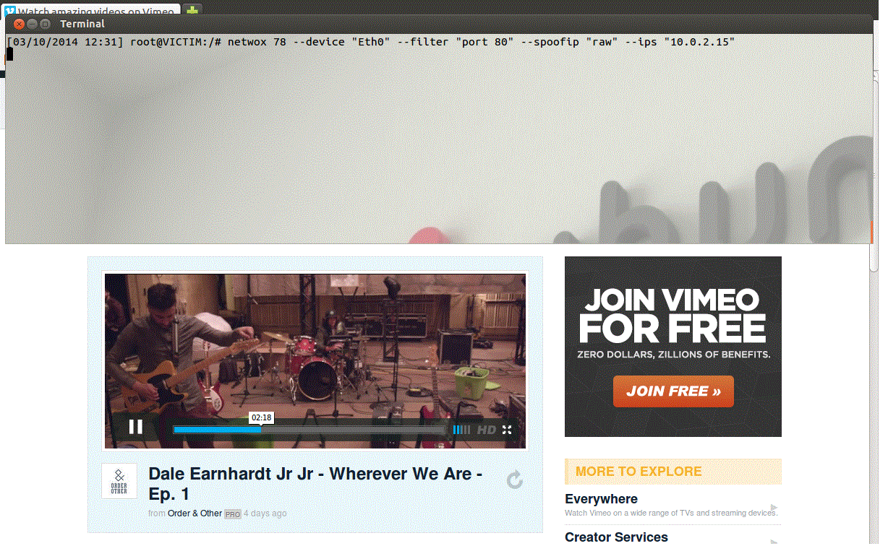

**Observation:**

After the connection is terminated through forged TCP RST the video plays as long it was streamed before the attack.



**Observation:**

Once the stream ends the video stops as if the entire video session has ended.

**With two VMs**

1. After the attack, what happened to the video? Can you still watch it?



**Observation:**

When another machine tries to send the forged TCP packet to the victim the reset packet will not delivered as the packets cannot be captured in a NAT network. This is because the promisc mode in NAT is denied by default.

**Task 6: ICMP Blind Connection-Reset attack**

The ICMP blind connection reset packets are sent if there are any hard errors such as destination unreachable, protocol unreachable, port unreachable, fragmentation needed and DF bit set. When any of these hard errors occur the machine will abort the TCP connection immediately.

1. Can you issue the attack packets?

The attacker can send the blind connection reset packet to the victim using netwox 82 tool. The syntax of the command is,

netwox 82 --device<”device”> --filter <source/destination IP> --src-ip <sender’s IP> --spoofip <

packet type>

1. Does it work on telnet?

ICMP blind connection attack can be used to disconnect telnet connection between two computers.

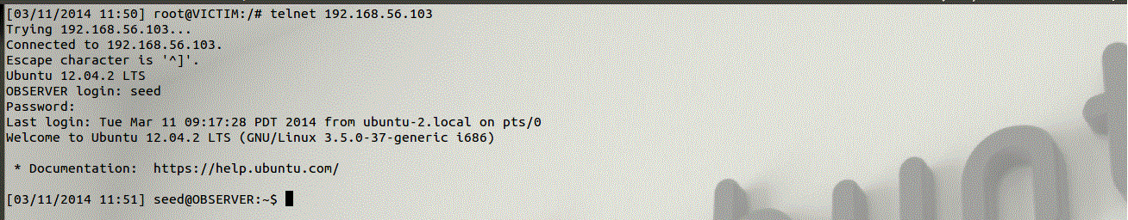

**Observation:**

When there is no attack the victim can telnet to the observer and establish the connection.

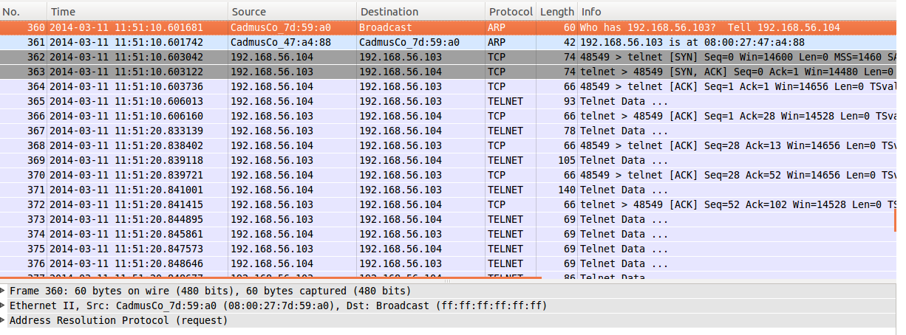

**Observation:**

The attacker watches the telnet packets sent between victim and observer. The attacker can use it to spoof a ICMP blank connection reset packet.



**Observation:**

The attacker generates ICMP blank connection reset packet and sends it to the victim machine as if the observer is sending the reset packet.



**Observation:**

When the victim telnet’s again to the observer it is unable to connect. This is because of the attackers reset packet.

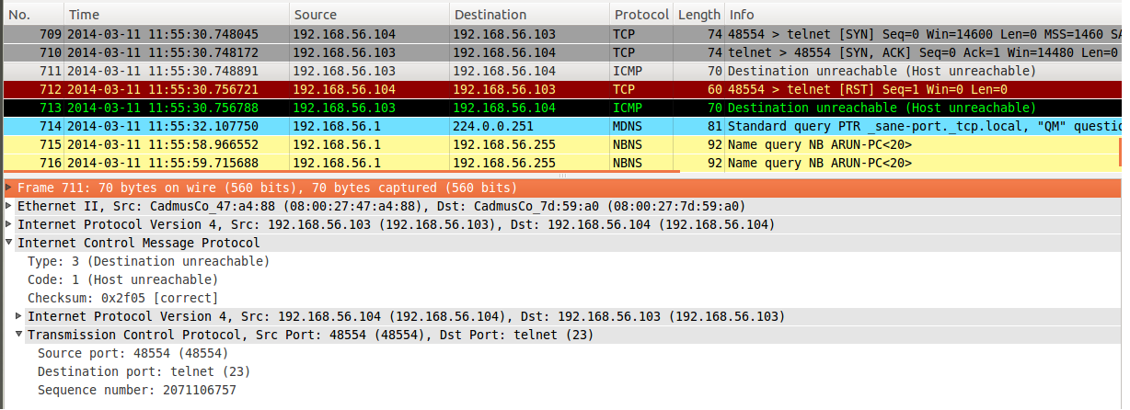

**Observation:**

The attacker watches the reset packet terminating the telnet connection. ICMP type : 3, code : 1 are related to one of the hard errors.(destination host unreachable)

However when the victim machine completes the telnet connection and enters into the observer the blind connection reset cannot be used to disconnect the connection.

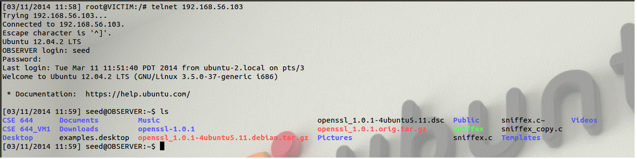

**Observation:**

The victim has made the telnet connection to the observer. It can view or modify the contents in the observer.



**Observation:**

The attacker generates the icmp blind connection reset packets.

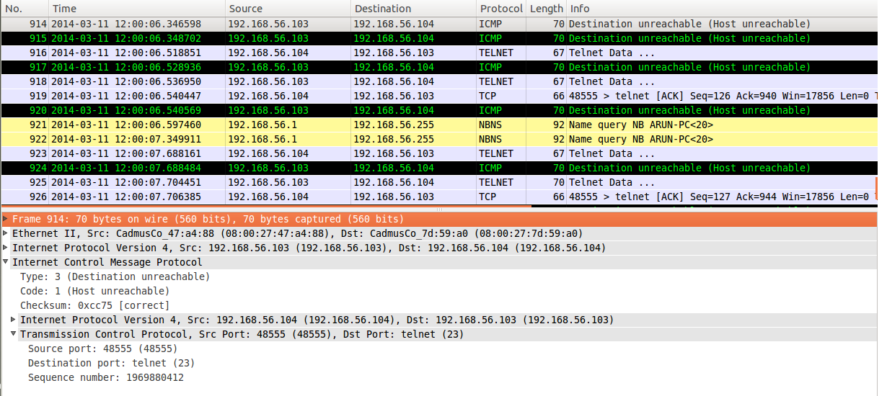

**Observation:**

The attack won’t work since the victim is in the observer

1. Does it work for online video?

Online videos can be prevented from streaming further by sending icmp blind connection reset packet. However such attacks can be done only on the same machine or else the packet will not be captured and the attack cannot be made.

1. Before visiting online video page?



Observation:

The attack packets are generated and sent before the video begins to stream.



**Observation:**

The video does not stream since the attack packets tries to close the connection.

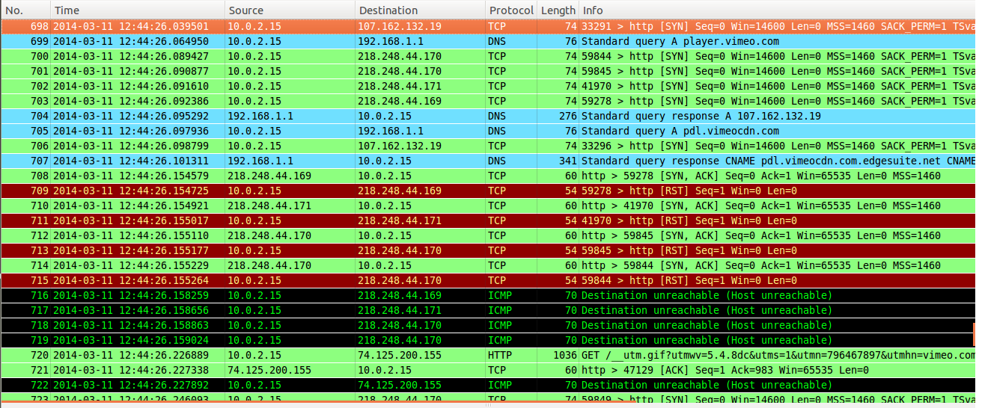

**Observation:**

The victim can see the blind reset packets terminating the connection.

1. After the video gets started?
2. FTP?

File Transfer Protocol is a TCP based network protocol which is used to transfer files from one machine to the other. ICMP blind connection reset attack can be used to terminate such ftp connection between two machines.

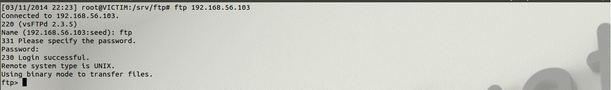

**Observation:**

When there is no blind reset attack the victim can successfully connect to the observer through the ftp connection.

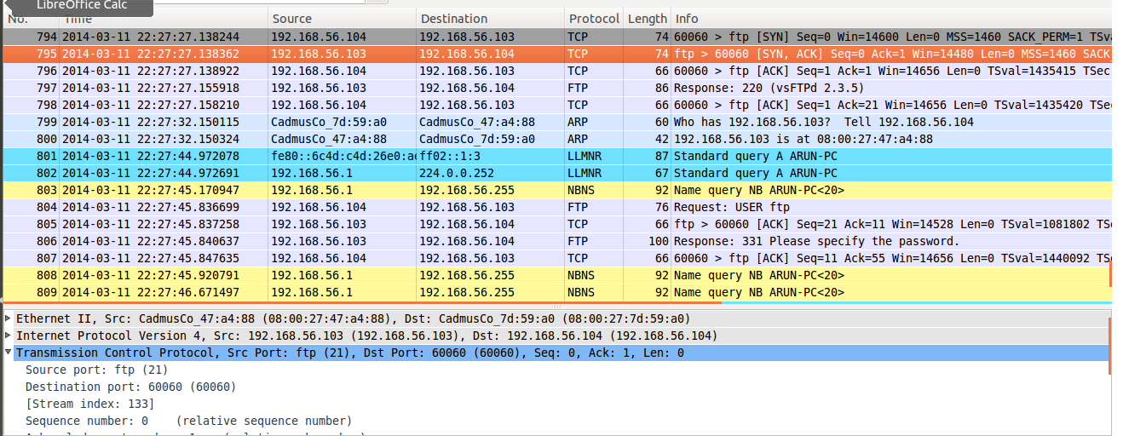

**Observation:**

The attacker watches the ftp packets sent between the two machines and the TCP 3-way handshake.



**Observation:**

The attacker generates the destination host unreachable packet in which the sender is the observer. The code value must be 1 to indicate that the destination host is unreachable. Different codes are used based on the type of attack such as code 2 for port unreachable.



**Observation:**

When the victim tries to make a FTP connection it is aborted with the message that the destination host could not be reached.

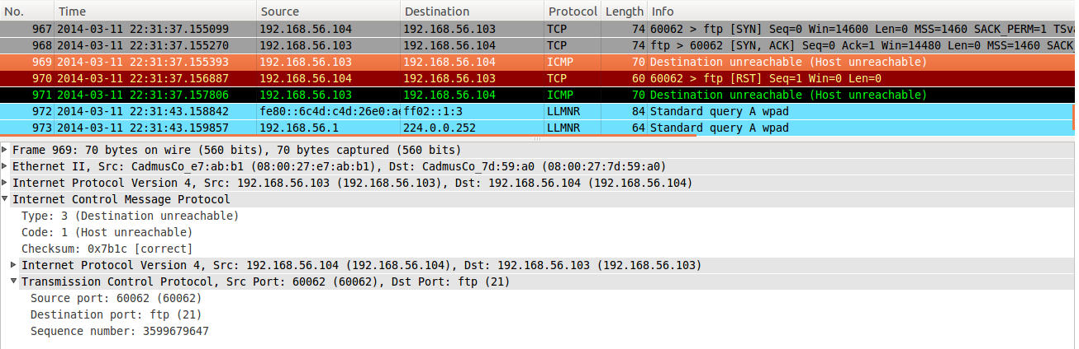

**Observation:**

The attacker can see the icmp packets specifying that observer is unreachable. The issue with this attack is that the attack must take place before the 3-way handshake is complete so that the victim will send the TCP reset packet to terminate the connection or else the attack won’t be successful.

**Task 7: source-Quench attack**

1. Can you issue the attack packets?

The attacker can use the netwox 85 tool to send out the source quench ICMP packet with the source IP as one of the two hosts. The syntax is

Netwox 85 --device <“filter device”> --filter <“IP address”> --src-ip <other IP address> --spoofip <”packet type”>

1. Does it work for telnet?

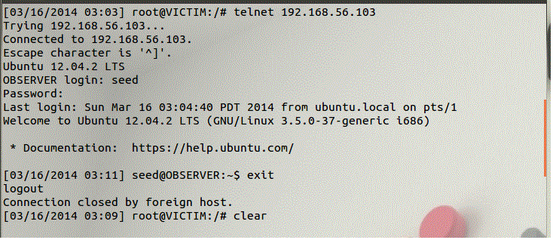

**Observation:**

Before the attack the victim machine telnets to the observer machine.

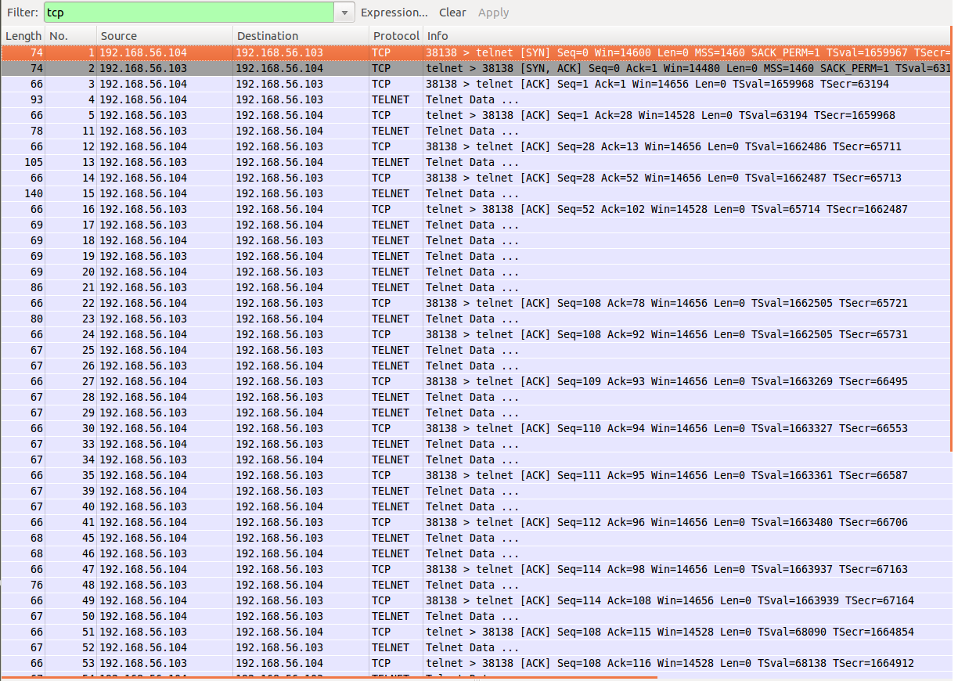

**Observation:**

The attacker watches the packets being sent between the victim and the observer. As the attacker did not forge the source quench packet there is no delay in sending packets.

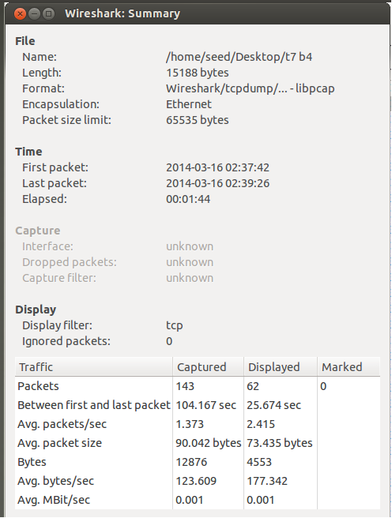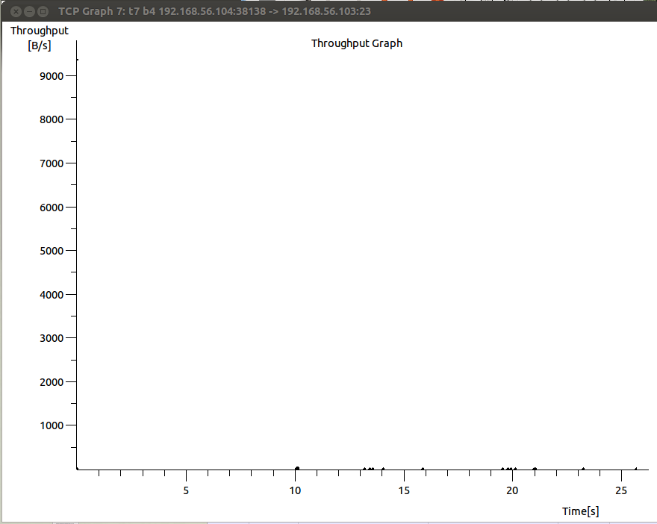

**Observation:**

Since there is no attack there is any delay in sending packet between the victim and observer.



**Observation:**

The attacker sends out the forged source quench packet to the victim with the IP address of the observer using the netwox.

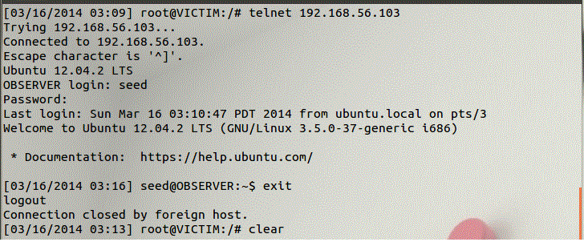

**Observation:**

Unknown of the attack the victim again telnets the observer.

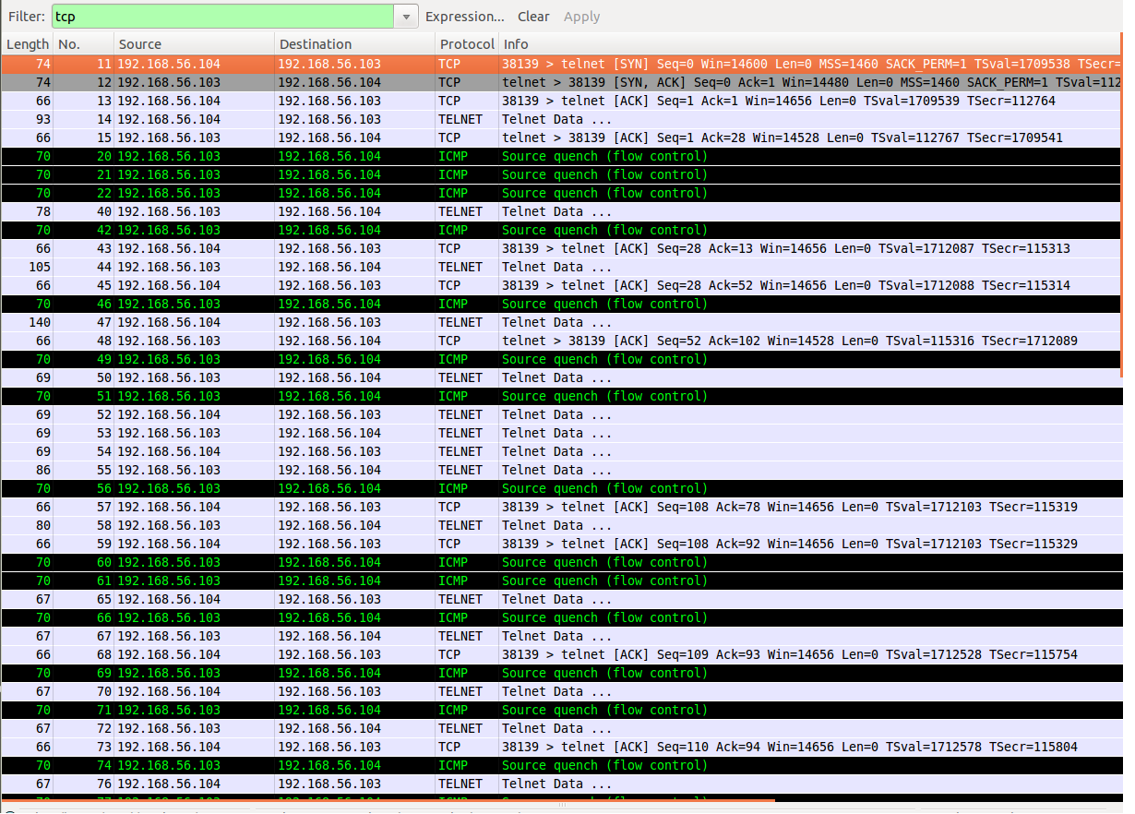

**Observation:**

The attacker can see the ICMP source quench packet being sent to the victim and the victim slowly delays sending the packets to the observer.

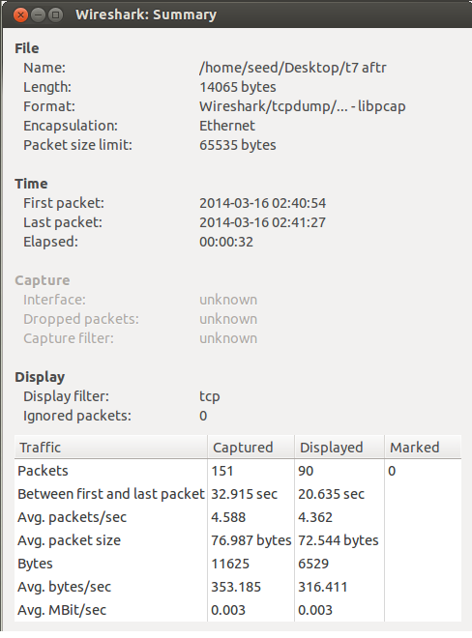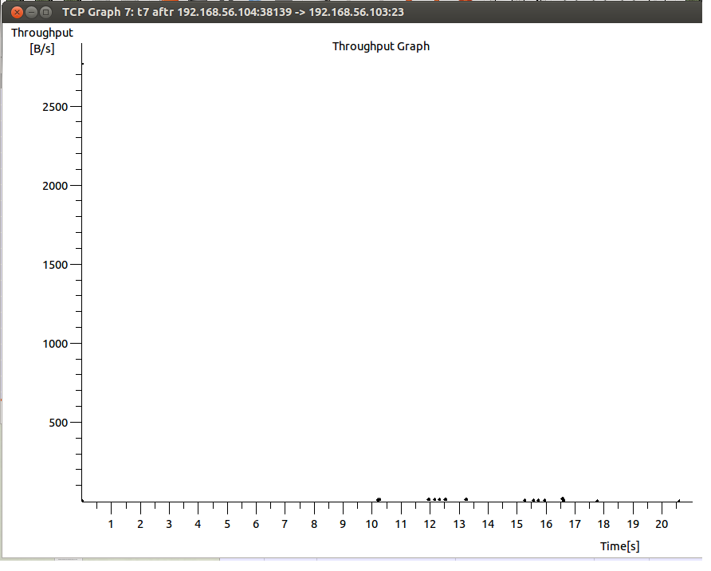

**Observation:**

The attacker can see the difference in the throughput and the increase byte transfer between the victim and observer.

1. Does it work for online video?

* **Before visiting online video page?**

The victim machine sends out source quench packet before streaming online video.



**Observation:**

The used netwox 85 to forge a source quench packet.

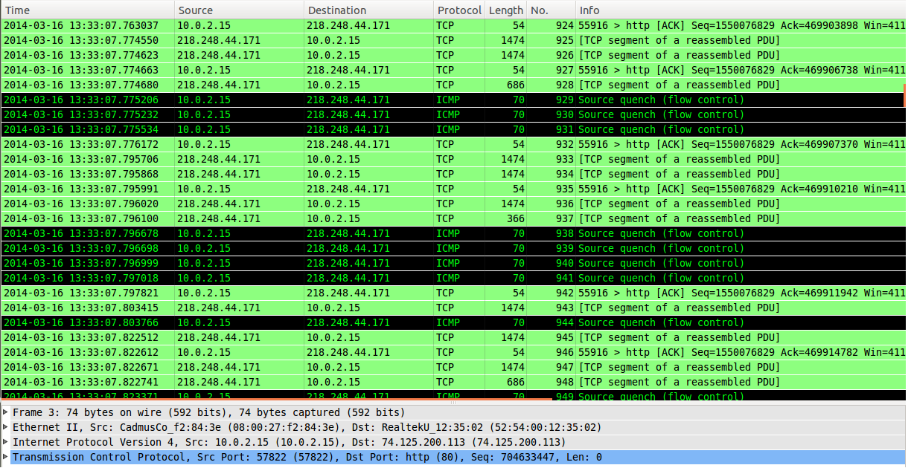

**Observation:**

The victim can see the source quench being sent to the sender.



**Observation:**

As the source quench reduced the rate of packets being sent the online video is streamed slowly.



**Observation:**

When the rate of packets being received reduces greatly the online video stops from buffering further.

* **After visiting online video page?**



**Observation:**

Before sending out the source quench packets the victim machine starts streaming the online video. As there is no restriction in the speed of transfer the video is buffered quickly.



**Observation:**

After the video gets streamed half way the victim starts sending out the source quench packets.

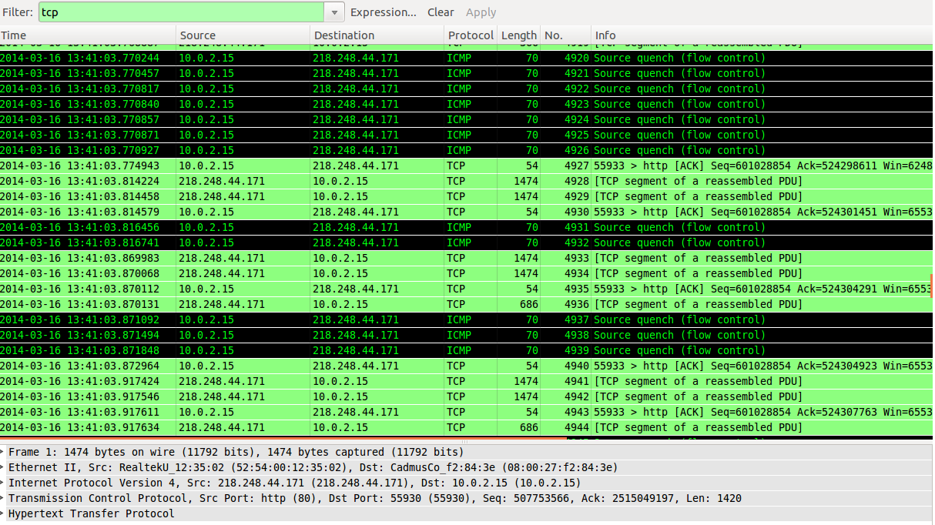

**Observation:**

The source quench packets are sent to reduce the speed of byte transfer.



**Observation:**

The buffering speed gets reduced due the source quench packets and at one instant the video stops to buffer further.

1. FTP?

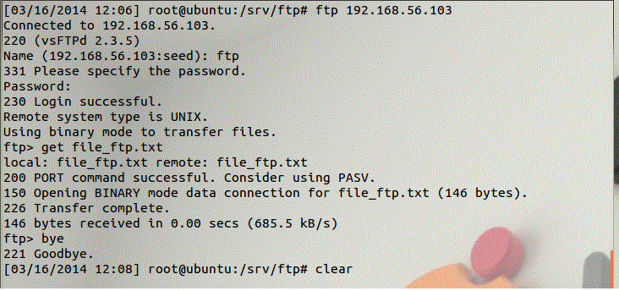

**Observation:**

Before the attack the victim machine connects with the observer through the FTP connection and gets a file from the observer. The number of bytes received is at the rate of 685.5 kb/s.

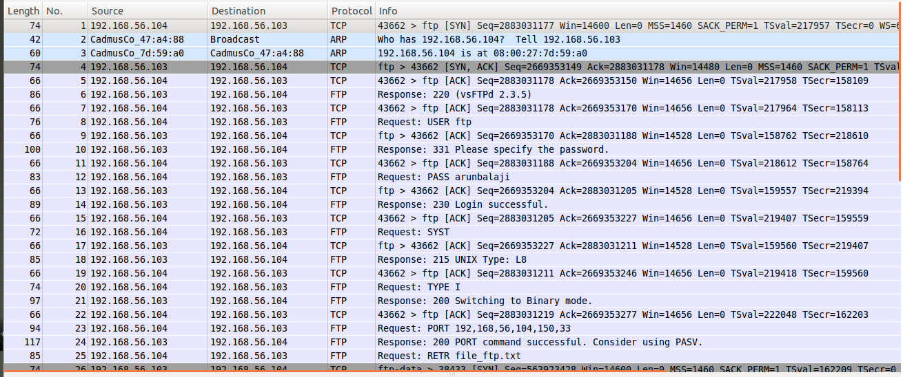

**Observation:**

The attacker watches the FTP packets sent between the observer and victim.

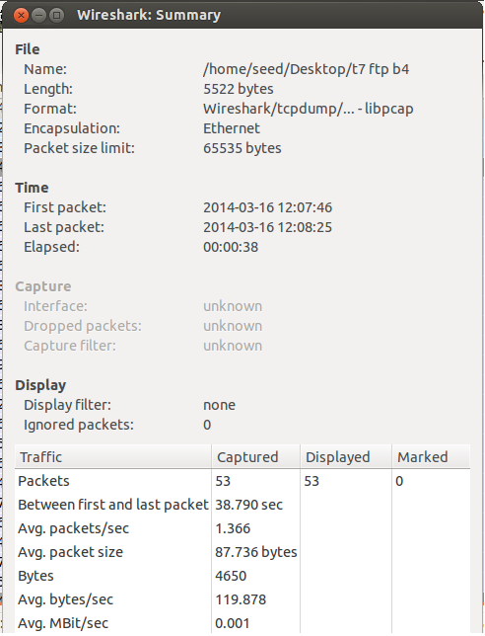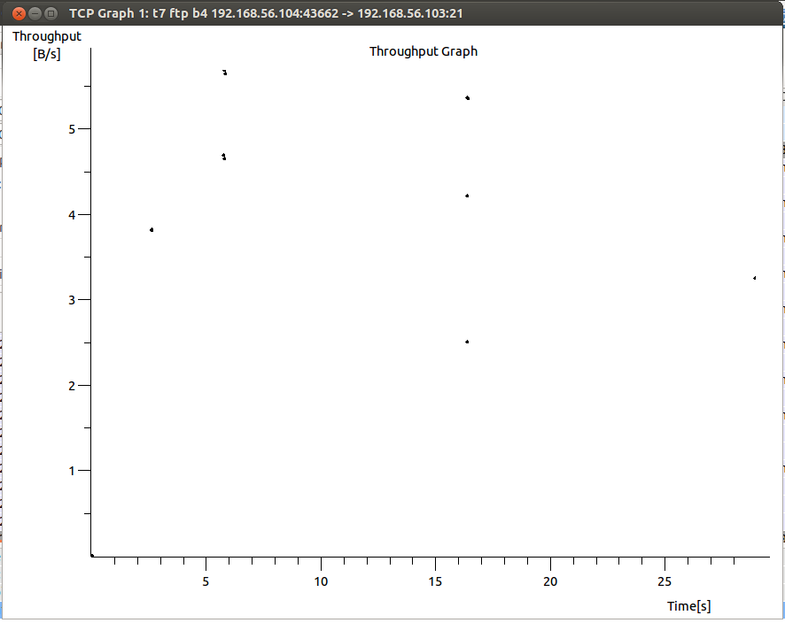

**Observation:**

The attacker can see the average bytes tranfered and throughput between the two machines.



**Observation:**

The attacker forges an ICMP source quench packet with the source IP of the observer.

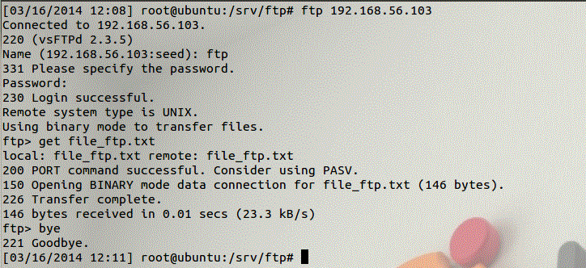

**Observation:**

When the victim again makes a FTP connection with the observer and gets the file the byte transfer is greately reduced. The number of bytes received is at the rate of 23.3 kb/s.

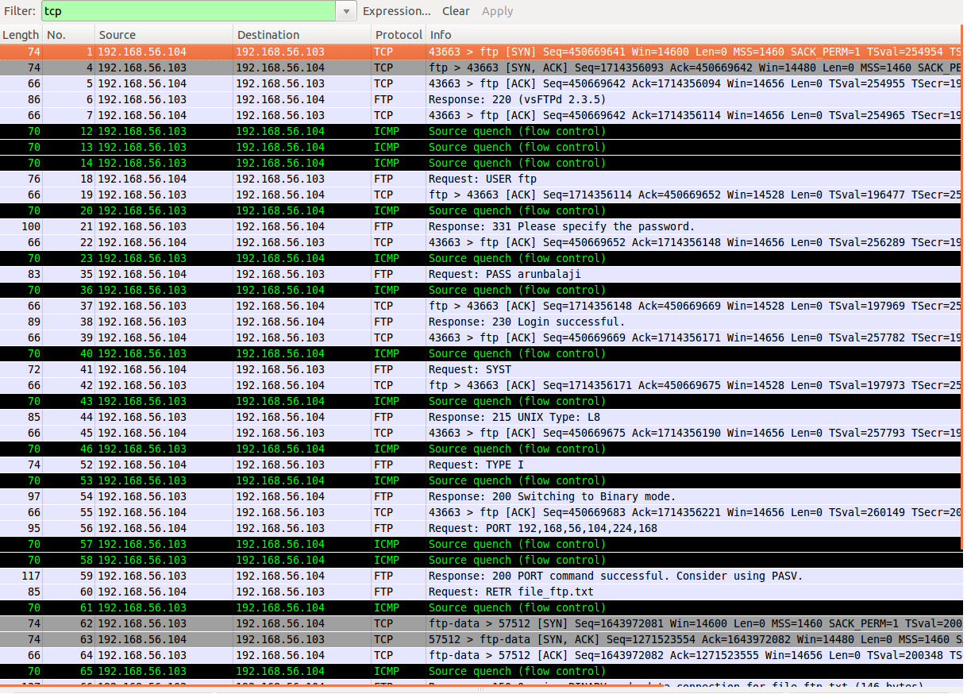

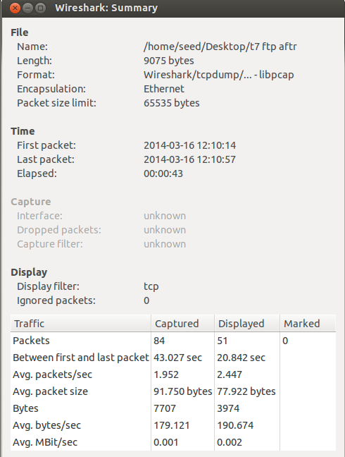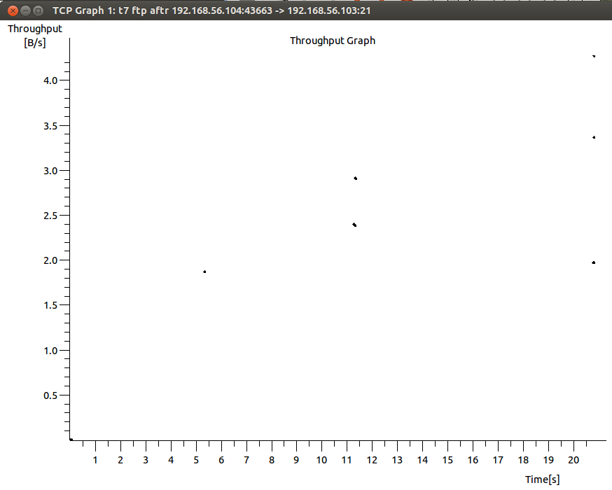

**Observation:**

The attacker can see the forged source quench packets being sent to the victim from the observer asking to reduce the speed the packet transfer. The attacker can see the difference in the throughput and the increase byte transfer.

**Task 8: TCP Session Hijacking**

TCP session hijacking is a process in which an attacker can intercept a TCP session between two machines. Since the authentication check is performed only during session initialization the attacker can perform the attack after some duration. The attacker gets the current value of the absolute sequence and acknowledgement number of the TCP session and forges a TCP packet with the next sequence and acknowledgement number and sends it to one of the two machines.

1. Can you issue the attack packets?

The attacker uses the netwox 40 tool to send a fake packet on the network. The syntax of the command is,

netwox 40 --ipv4-tos <DSCP value> --ipv4-id <the next id number> --ipv4-<flag> --ipv4-<frag offset> <bit>--ipv4-ttl <value> --ipv4—protocol <value> --ipv4-src <source IP > --ipv4-dst <destination IP> --tcp-src <port no.> --tcp-dst <port no.> --tcp-seqnum <next seq num> --tcp-acknum <next ack num> --tcp-<flag> --tcp-window <window size> --tcp-data <data> --spoofip <”type of packet”> --ipv4-totlen <length> --ipv4-checksum <value>.

1. Establish telnet connection

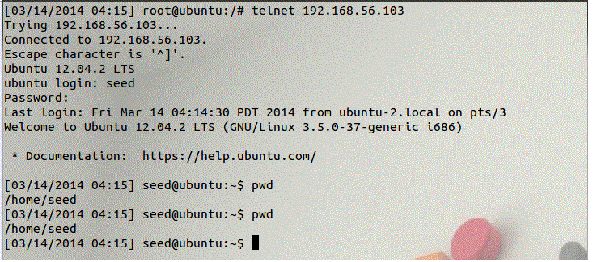

**Observation:**

The victim 192.168.56.104 makes a telnet connection to the observer 192.168.56.103.

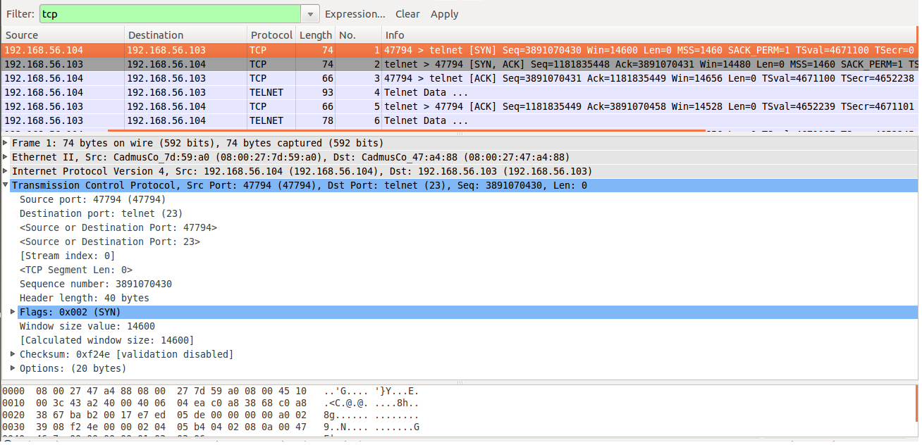

**Observation:**

The victim uses the available port 47794 and provides an initial sequence number 3891070430 to the observer.

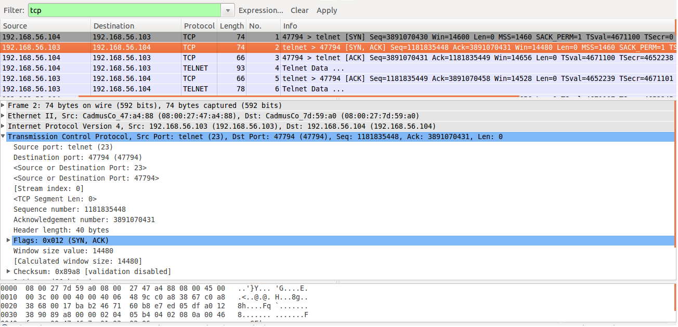

**Observation:**

The observer acknolwleges the victim’s TCP packet by sending the ack packet with the sequence number : 1181835448 and acknowledgement number as victim’s sequence number plus 1 since there are no other packets in between.

1. Check the wireshark setting to see the absolute value of seq and ack.

The victim machine changes its wireshark setting to see the absolute value of the seq and ack numbers.

Edit -> preferences -> protocols -> TCP uncheck relative sequence number.

1. Check the last sequence number and acknowledgement number used by client.

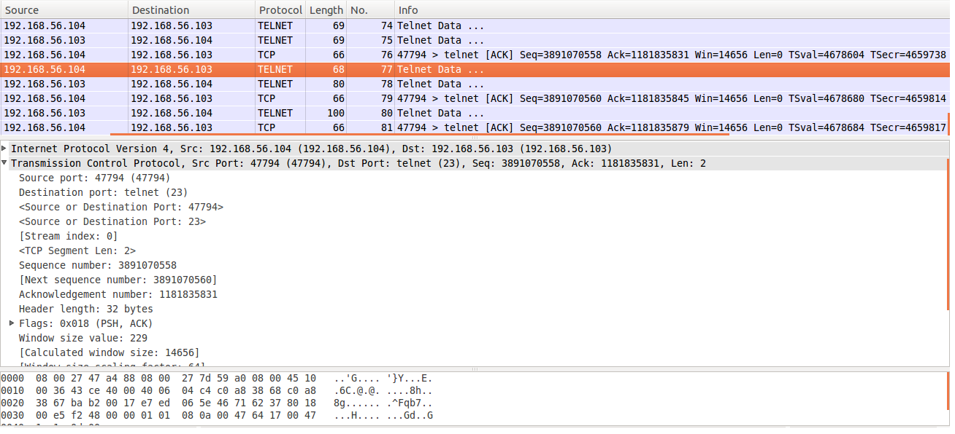

**Observation:**

The last sequence number used by the victim is 3891070558, the next sequence number: 3891070560 and acknowledgement number: 1181835831.

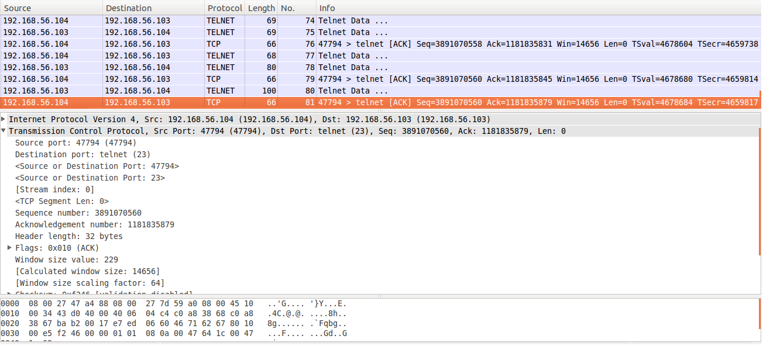

**Observation:**

The victim acknowledges with the acknowledgement number: 1181835879.

1. Seq > last_seq; ack > last_ack

After getting the next sequence and acknowledgement number the attacker forges a TCP packet using netwox

40 with the sequence number: 3891070560 acknowledgement number: 1181835879. The payload value is

“’pwd’ 0d0a” to print the working directory of the observer.

h) Can you succeed?

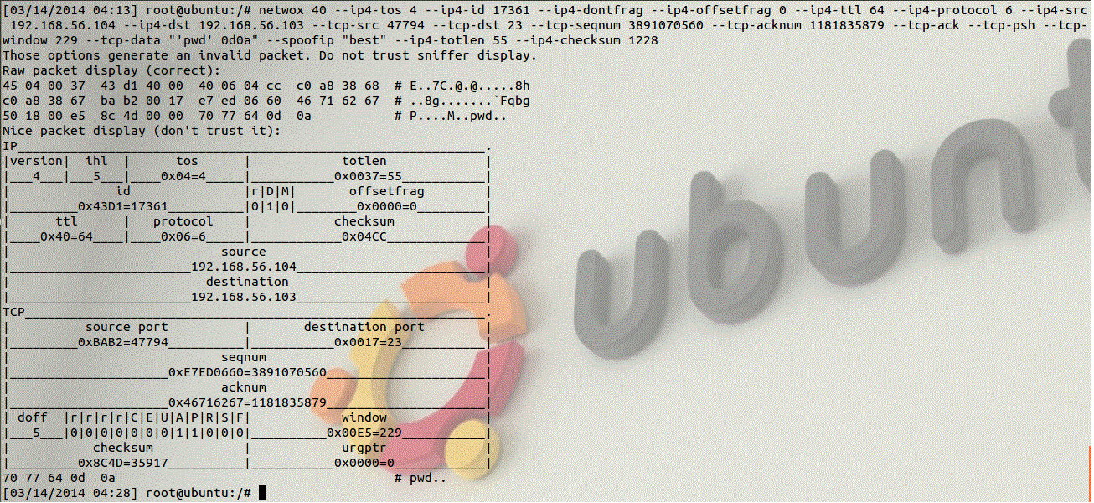

**Observation:**

The attacker has successfully forged and sent a telnet packet to the observer with the next identification number: 17361

1. What do you observe from the victim machine?

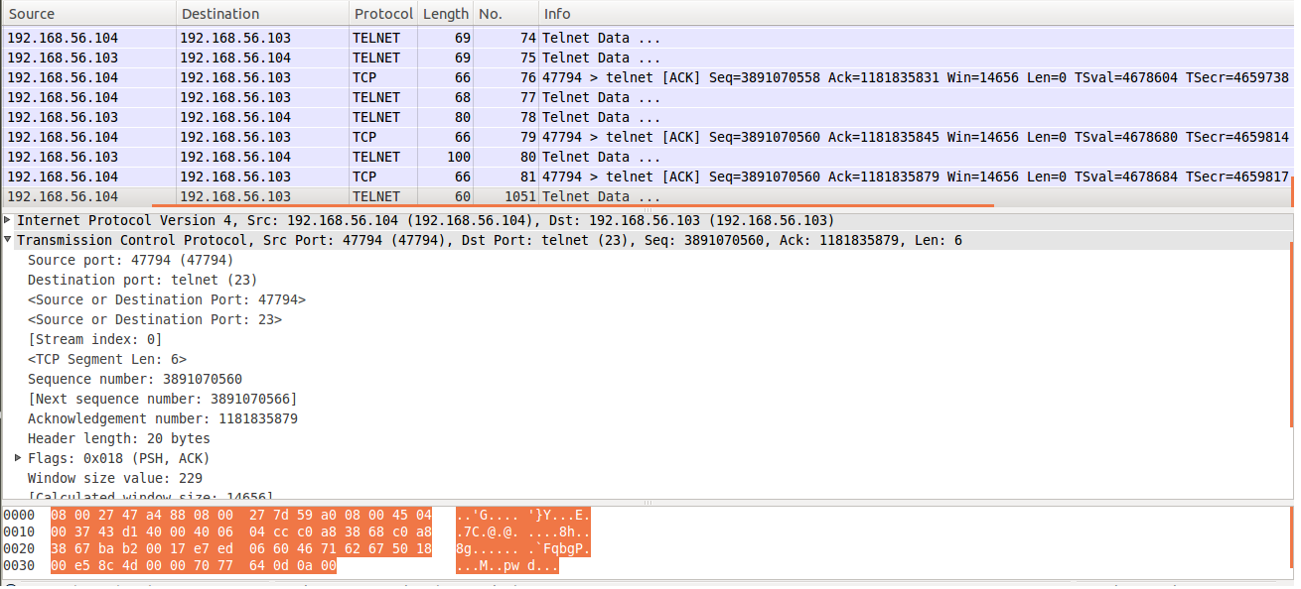

**Observation:**

The forged packet can be seen in the victim’s wireshark (packet no.1051)

j) How about the telnet connection? Is it still alive?

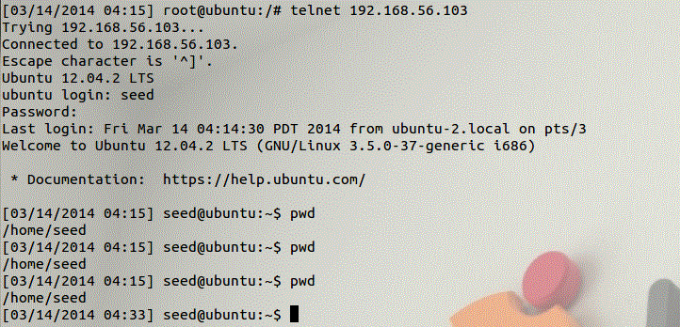

**Observation:**

Unknown of the attack the victim sends out a telnet packet to get the current working directory of the observer.

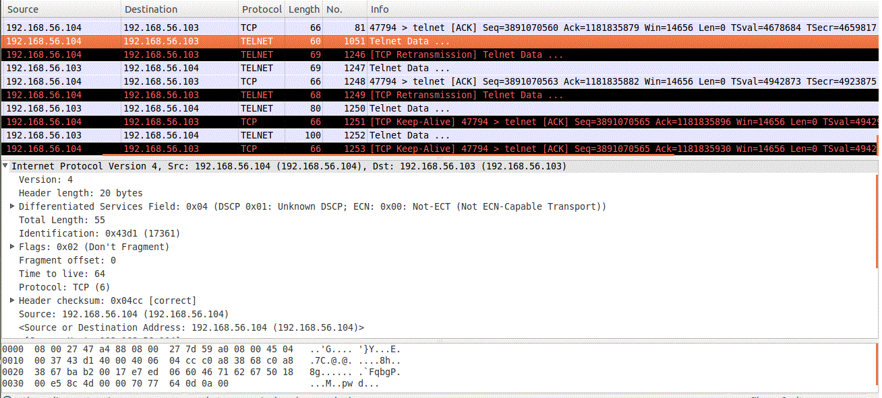

**Observation:**

The victim sends out a telnet packet with the ID number: 17361.

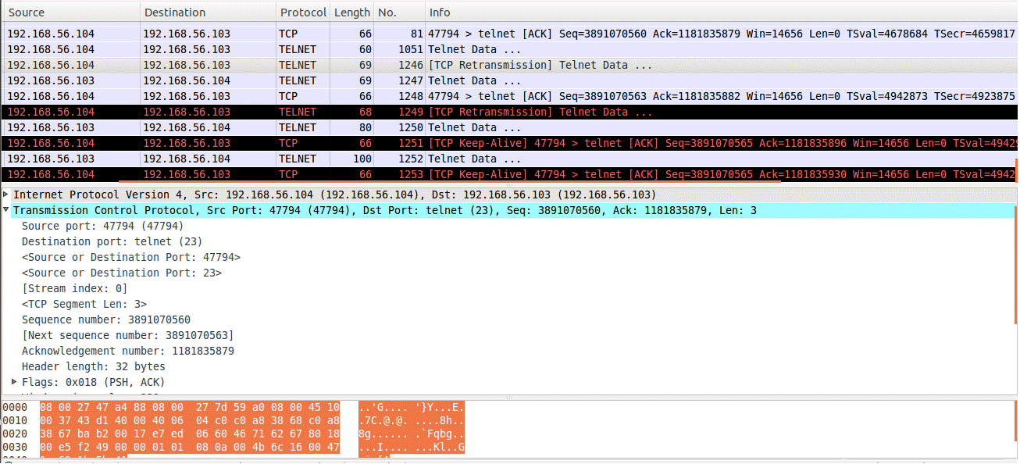

**Observation:**

The victim uses the sequence number: 3891070560 acknowledgement number: 1181835879 which was used by the attacker so the packet is taken as a retransmission.

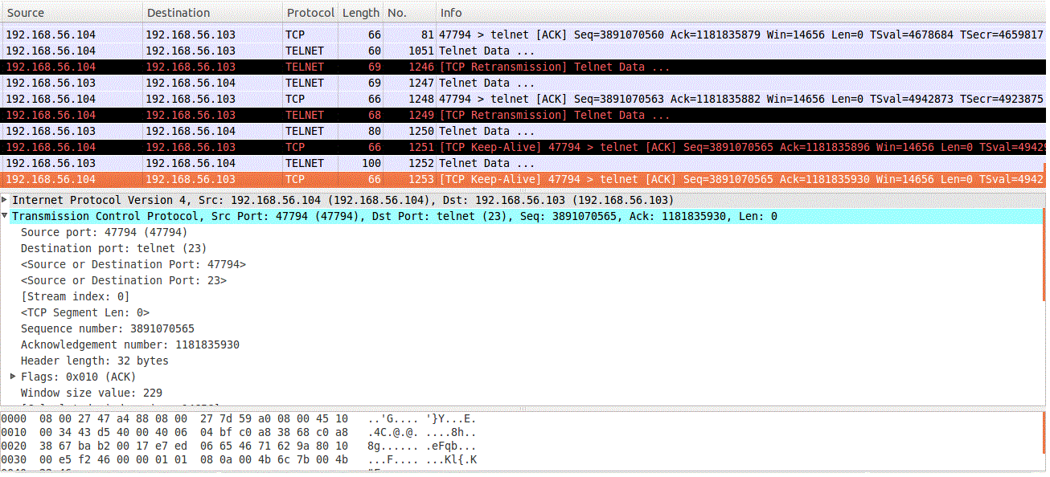

**Observation:**

The victim acknowledges with the sequence number: 3891070563 and acknowledgement number: 1181835930. This can again be used by the attacker to forge further packets.

**Investigation:**

**Sequence Numbers:**

Every time when a new telnet connection is made between two machines a new 32-bit initial absolute

sequence number is generated.

1. What’s your observation?

The range of the absolute sequence number is from 0 to 4294967295. If the

number reaches the limit (FFFFFFFF) it cycles back to zero. In the above case the victim generates a two

sequence numbers (current, next) and an acknowledgement number while sending telnet packets. The

observer uses the ack of the victim as its current seq and victim’s next seq number as its ack. Again the

victim uses the observer’s next seq number as its ack and observer’s ack number as its current seq number.

1. What’s your conclusion? Are you able to guess it?

The initial sequence number is randomly generated by the machine so the attacker is unable to guess the initial sequence number however after the packets are transferred between the two machines the attacker can guess the next sequence and acknowledgement number based on the number of packet sent by the two machines.

**TCP window size:**

The window size is the amount of data that a machine can receive without sending an acknowledgement back

to the sender.

1. What’s the default value on Ubuntu?

The default TCP window size on ubuntu is 128 kbytes.

1. What’s the default value on Windows?

The default TCP window size on windows is 17 kbytes.

1. What’s your conclusion?

Ubuntu can receive larger bytes before sending acknowledgement to the sender.

**Port number:**

Port numbers are addressing information that are used to identify the senders and receivers messages. The port

number ranges from 0 to 65535.

1. What’s your observation?

Each time a new telnet connection is made the TCP uses different port numbers.

1. What’s your conclusion? Are you able to guess it?

The TCP assigns first port number randomly based on the available port numbers. Every successive tcp connection uses a different port number which is higher than the last port number. If a telnet connection is disabled and enabled again the new port number will be a few increment(+1) of the old port number.